L.J INSTITUE OF COMPUTER APPLICATION



VOCO - Native Language Learning Platform

Developed By:

Krishna Radhani: 22002501210028
Meet Patel: 22002501210067
Yash Shah: 22002501210056

Under the Guidance of:

Prof. Rita Gokani

L.J SCHOOL OF COMPUTER APPLICATION
LJ Campus, LJ University Road, Off S.G. Road, Ahmedabad-382210

CERTIFICATE
Enrolment No: 22002501210028
This is to certify that Mr. Krishna Radhani of Integrated Master of Computer Applications (IMCA), Semester 9, Roll No B-24, has satisfactorily completed his project titled VOCO under the supervision of Prof. Rita Gokani
Internal Guide Name | Head of Department
Prof. Rita Gokani | DR. Monica Gahalawat

SIGNATURE
Date of Submission:
DIRECTOR
Prof. Alok Manke

L.J SCHOOL OF COMPUTER APPLICATION

L.J SCHOOL OF COMPUTER APPLICATION
LJ Campus, LJ University Road, Off S.G. Road, Ahmedabad-382210

CERTIFICATE
Enrolment No: 22002501210067
This is to certify that Mr. Meet Patel of Integrated Master of Computer Applications (IMCA), Semester 9, Roll No B-37, has satisfactorily completed his project titled VOCO under the supervision of Prof. Rita Gokani
Internal Guide Name | Head of Department
Prof. Rita Gokani | DR. Monica Gahalawat

SIGNATURE
Date of Submission:
DIRECTOR
Prof. Alok Manke

L.J SCHOOL OF COMPUTER APPLICATION

L.J SCHOOL OF COMPUTER APPLICATION
LJ Campus, LJ University Road, Off S.G. Road, Ahmedabad-382210

CERTIFICATE
Enrolment No: 22002501210056
This is to certify that Mr. Yash Shah of Integrated Master of Computer Applications (IMCA), Semester 9, Roll No B-54, has satisfactorily completed his project titled VOCO under the supervision of Prof. Rita Gokani
Internal Guide Name | Head of Department
Prof. Rita Gokani | DR. Monica Gahalawat

SIGNATURE
Date of Submission:
DIRECTOR
Prof. Alok Manke

L.J SCHOOL OF COMPUTER APPLICATION

Table of Contents
1. Introduction 8
1.1 Project Profile 8
1.2 Existing System 9
1.3 Need for the New System 9
1.4 Problem Definition 9
1.5 Objective of the New System 10
1.6 Scope of the Project & Core 10
1.6.1 Scope of the Project 10
1.6.2 Core of the Project 10
1.7 Feasibility Study (Technical / Economical / Operational) 11
1.8 Advantages and Limitations 12
1.8.1 Advantages 12
1.8.2 Limitations 12
1.9 Assumptions and Constraints 12
1.9.1 Assumptions 12
1.9.2 Constraints 12
1.10 Stakeholder Analysis & RACI matrix 13
1.10.1 Stakeholder Analysis 13
1.10.2 RACI (Responsible, Accountable, Consulted, Informed) 13
2 Requirement Determination & Analysis 14
2.1 Functional Requirements 14
2.2 Non-Functional Requirements 14
2.3 Targeted Users 15
2.4 Software Requirement 15
3 Project Planning & Management 16
3.1 Project Charter 16
3.1.1 Project Stakeholders 16
3.1.2 Project Description 16
3.1.3 Measurable Organizational Value (MOV) 17
3.1.4 Project Scope 18
3.1.5 Project Schedule Summary 19
3.1.6 Project Budget Summary 19
3.1.7 Quality Issues 19
3.1.8 Resource Required 20
3.1.9 Assumptions and Risks 21
3.1.10 Project Administration 22
3.1.11 Acceptance & Approval 23
3.2 Project Lifecycle Model 24
3.3 Work Breakdown Structure 24
3.4 Effort Estimation 28
3.5 Gantt Chart / Sprint Schedule 29
3.6 Sprint Backlog 34
3.7 User Stories 37
3.8 Release Plan 39
3.9 Risk Register 42
3.10 Change Request Log 47
3.11 Status Reports 47
3.11.1 Status Report – August 2026 47
3.11.2 Status Report – September 2026 48
3.11.3 Status Report – October 2026 49
4 System Design 50
4.1 System Architecture 50
4.1.1 Overview 50
4.1.2 Components of System Architecture 50
4.1.3 System Architecture Diagram 52
4.1.4 Working of the System 52
4.2 Module Description 53
4.2.1 User Authentication and Profile Management Module 53
4.2.2 Language and Chapter Management Module 53
4.2.3 Vocabulary Learning Module 53
4.2.4 Multiple-Choice Questions (MCQ) Module 53
4.2.5 Examination and Progress Tracking Module 53
4.2.6 AI-Based Voice Conversation Module 53
4.2.7 Conversation History and Performance Evaluation Module 53
4.2.8 Dashboard Module 53
4.2.9 Administrative Management Module 53
4.2.10 User Interface Language Management Module 54
4.2.11 Database Management Module 54
4.3 Use Case Diagram 55
4.4 Class Diagram 56
4.5 Interaction Diagram 57
4.6 Activity Diagram 59
4.7 Data Dictionary 62
5 Development 67
5.1 Coding Standards 67
5.2 SOLID Principles & Refactoring 67
6 Design Pattern Implementation & Documentation 69
6.1 Pattern Selection & Justification 69
6.2 Creational Pattern 69
6.3 Structural Pattern 70
6.4 Behavioral Pattern 70
6.5 UML Mapping (Pattern-to-Class Diagram Traceability) 70
6.6 Documentation & Trade-off Analysis 71
6.7 Testing 73
6.8 Project Tracking & Monitoring 76
6.9 Screenshots 77
6.10 Proposed Enhancement 88
6.11 Project Closure Report 88
6.12 Conclusion 88
6.13 Bibliography 88

Introduction

The VOCO project is focused on developing an online language learning platform that responds to the growing need for accessible, effective, and engaging education. By offering a digital space where learners can practice reading and listening through interactive lessons and real-life conversations, VOCO aims to enhance language proficiency and learner confidence. The platform is designed not only for individuals seeking immediate learning support but also for those who wish to manage and improve their language skills on an ongoing basis, with easy access to expert-guided resources and structured learning paths.
VOCO is a transformative learning platform created to simplify and modernize the language learning experience. Through an intuitive and user-friendly application, VOCO enables users to register, personalize their learning journey, access lessons, and practice communication skills anytime and anywhere. This innovative approach removes traditional learning barriers and empowers users by giving them greater control over their learning pace, goals, and progress. By bringing multiple learning tools into a single platform, VOCO makes it easier for learners to manage their language development effectively.
The initiative is driven by the goal of improving access to quality language education through technology, addressing the increasing demand for flexible and online learning solutions. In today’s fast-paced world, where convenience and adaptability are essential, VOCO provides learners with a reliable platform to build and strengthen their native language skills. With expert guidance, interactive features, and practical learning experiences, VOCO empowers users to take an active role in their language journey and communicate with confidence in everyday life.

Project Profile

Project Title | Voco
Type of Application | Web Application
Duration | 3 Months
Team Size | 3 People
Front End | HTML, CSS, React.Js
Back End | Node.Js, Express.Js
Database | MongoDB
Tools Used | VS Code, GitHub, Postman
Project Internal Guide | Pro. Rita Gokani

Existing System
Traditional language learning is primarily conducted through in-person and offline methods.
- Classroom-Based Learning: Learners attend physical language institutes or classrooms to enroll in language courses.
- Direct Interaction: Students interact face-to-face with instructors to learn grammar, vocabulary, pronunciation, and conversational skills.
- Printed Learning Materials: Books, worksheets, and printed exercises are commonly used to support learning.
- Practice Sessions: Learner’s practice speaking and listening through classroom activities, role-plays, and group discussions.
- Assessment Process: Tests and evaluations are conducted manually by instructors to assess learner progress.

Need for the New System

- Rising Costs of Traditional Learning: Conventional language learning methods such as classroom courses and private tutoring are becoming increasingly expensive, creating a need for a more affordable learning solution.
- Changing Learning Landscape: The rapid growth of digital education platforms has increased competition and user expectations, highlighting the need for a modern, technology-driven language learning approach.
- Affordable Learning Options: The new system aims to provide cost-effective language learning opportunities without compromising the quality of education.
- Wider Learning Resources: An online language learning app can offer a wide range of lessons, exercises, and practice modules tailored to different proficiency levels and learning styles.
- Convenient Access: Learners can access language lessons anytime and anywhere, eliminating the need for physical attendance.
- Detailed Learning Content: The app will provide comprehensive explanations, audio pronunciations, interactive exercises, and cultural context to help learners understand and use the language effectively.
- Easy Enrolment and Progress Tracking: Users can easily register, select learning paths, and track their progress through automated assessments and performance reports.
- Enhanced Learner Satisfaction: Improved accessibility, flexibility, and affordability will lead to higher learner engagement and satisfaction.
- Market Relevance: Implementing this system will help position the native language learning app as a modern, user-friendly, and competitive solution in the evolving digital education market.

Problem Definition
Traditional native language learning methods rely heavily on classroom-based instruction, physical learning materials, and fixed schedules. These methods are often expensive, time-consuming, and inaccessible to many learners due to geographical, financial, or time constraints. Additionally, learners receive limited personalized attention, delayed feedback, and fewer opportunities for consistent practice outside the classroom. This creates a need for a modern, digital solution that provides affordable, accessible, interactive, and effective native language learning experiences.

Objective of the New System

- To develop a user-friendly native language learning application that is accessible anytime and anywhere.
- To provide affordable and high-quality language learning resources for users of all age groups.
- To promote effective learning through interactive lessons, audio-visual content, and practice exercises.

- To support learners at different proficiency levels, from beginners to advanced users.

- To enable personalized learning paths based on user performance and progress.

- To automate assessments and provide instant feedback to enhance learning efficiency.

- To track learner progress and generate performance reports for continuous improvement.

- To preserve and promote native languages by making learning engaging and widely accessible.
- To provide an AI-powered one-to-one speech-to-speech conversation feature for interactive language practice.

Scope of the Project & Core

1.6.1 Scope of the Project
The scope of the VOCO project is to develop a web-based native language learning platform that enables users to learn, practice, and improve language skills through an interactive and personalized learning experience. The platform provides secure user registration, profile management, structured learning modules, pronunciation support, vocabulary and grammar lessons, video-based learning, MCQ assessments, and real-time progress tracking. It also includes an administrator panel for managing users, languages, learning content, chapters, vocabulary, and quizzes. The system is designed to be accessible anytime and anywhere, offering affordable, flexible, and engaging language education while supporting multiple native languages and personalized learning paths. The application will be developed using the MERN stack (MongoDB, Express.js, React.js, and Node.js) to ensure scalability, maintainability, and a modern user experience.

1.6.2 Core of the Project
The core of the VOCO project focuses on providing an intelligent and user-centric language learning platform that combines structured educational content with interactive learning techniques. The main functionalities include:
- User Authentication & Profile Management – Secure registration, login, profile management, and learning goal customization.
- Personalized Learning Paths – Adaptive learning based on user progress and proficiency level.
- Language Learning Modules – Organized lessons covering alphabets, vocabulary, grammar, sentence formation, and conversation.
- AI-Based Pronunciation & Audio Support (planned enhancement) – Speech recognition and pronunciation feedback to improve speaking and listening skills.
- Interactive Practice & Assessments – MCQs, quizzes, fill-in-the-blanks, and other exercises with instant feedback.
- Progress Tracking Dashboard – Monitor completed lessons, scores, achievements, and learning performance.
- Admin Management System – Manage users, languages, chapters, learning content, vocabulary, videos, and quizzes.
- Multilingual Support – Learn multiple native languages with localized content and interface support.

Feasibility Study (Technical / Economical / Operational)

Feasibility Study
The feasibility study evaluates whether the VOCO – Native Language Learning Platform can be successfully developed and operated within the available technical resources, budget, and project constraints.

Technical Feasibility
The project is technically feasible because the required technologies and development tools are readily available to the project team. The platform is developed using the MERN stack, consisting of React.js, Node.js, Express.js, and MongoDB. The system also uses supporting technologies such as HTML5, CSS3, JavaScript, Git/GitHub, Visual Studio Code, and Postman.
The existing system includes user authentication, language management, learning content, video learning, MCQ examinations, progress tracking, administration, and text-to-speech functionality. AI One-to-One Conversation, will extend the platform using Speech-to-Text, AI-based conversation processing, and Text-to-Speech. The feature will be integrated incrementally through the Scrum development process.
The project team has the required development knowledge and tools to design, develop, test, and integrate these components. Therefore, the project is considered technically feasible.

Economic Feasibility
The project is economically feasible because most of the technologies and development tools used are open-source or available through free tiers. React.js, Node.js, Express.js, Git, GitHub, Visual Studio Code, and Postman do not require significant licensing costs for this project. MongoDB can also be used through its available free-tier services.
The primary expenses are related to infrastructure and any external services required for deployment or AI functionality. Since the project is being developed as an academic project, the overall development cost remains relatively low.
The expected benefits include providing an accessible digital language-learning platform and demonstrating the practical application of modern web and AI technologies. Therefore, the expected benefits justify the limited project expenditure, making the project economically feasible.

Operational Feasibility
The project is operationally feasible because VOCO is designed to provide a simple and user-friendly web-based learning environment. Users can register, select a learning language, learn words and grammar, watch educational videos, attempt examinations, track their progress, and manage their profiles.
Administrators can manage users, languages, chapters, learning content, and MCQs through the administration module. The new AI One-to-One Conversation feature will allow learners to practice conversational skills using voice interaction.
The system is intended for students, beginners, professionals, and language learners, and can be accessed through a modern web browser with an internet connection. The modular design also allows future features and improvements to be incorporated without redesigning the entire system.

Advantages and Limitations

1.8.1 Advantages
- Provides anytime and anywhere access to native language learning.
- More cost-effective compared to traditional classroom-based learning.
- Supports self-paced learning, allowing users to learn at their own convenience.
- Improves pronunciation and listening skills through native speaker audio support.
- Interactive exercises and instant feedback enhance learner engagement.
- Personalized learning paths based on user progress and performance.
- Progress tracking helps learners monitor improvement over time.
- Helps preserve and promote native languages through digital platforms.

1.8.2 Limitations
- Requires a smartphone or internet-enabled device for access.
- Limited effectiveness without regular practice and learner motivation.
- Lack of face-to-face interaction may affect learners who prefer classroom learning.
- Dependence on internet connectivity for updates and online features.
- Initial development and content creation require significant time and resources.

Assumptions and Constraints

1.9.1 Assumptions
- Users have access to a smartphone, tablet, or computer capable of running the application.
- Users possess basic digital literacy to navigate the app and use its features.
- Internet connectivity is available for initial registration, content updates, and online features.
- Learners are motivated to practice regularly for effective language acquisition.
- Audio and visual resources provided in the app accurately represent native language usage.
- The system will be used by learners of varying age groups and proficiency levels.

1.9.2 Constraints
- Limited internet connectivity may restrict access to online features and real-time updates.
- Device compatibility issues may arise across different operating systems and screen sizes.
- Development time and budget limitations may affect the number of features implemented.
- Data privacy and security.

Stakeholder Analysis & RACI matrix

1.10.1 Stakeholder Analysis

Stakeholder | Role | Interest | Influence
Students / Learners | Primary users of the platform | Learn native languages, track progress, complete quizzes | High
Administrator | Manages users, languages, chapters, learning content, and assessments | Ensure smooth platform operation and quality content | High
Project Team | Design, develop, test, and maintain the application | Successful project completion and delivery | High
Project Guide (Prof. Rita Gokani) | Provides technical guidance and project reviews | Ensure project quality and academic standards | Medium
LJ Institute / University | Academic stakeholder | Successful completion of academic project | Medium

1.10.2 RACI (Responsible, Accountable, Consulted, Informed)
Project Activity | Project Manager | Backend Developer | Frontend Developer | Database Integration | Client
Project Initiation | R/A | C | C | C | C
Requirement Gathering | R/A | C | C | C | C
System Design | R/A | R | R | R | C
Sprint Planning | R/A | R | R | C | C
Development | A | R | R | R | I
Testing & Bug Fixing | A | C | C | C | C
Sprint Review | R/A | C | C | C | C
User Acceptance Testing | R/A | C | C | C | R
Final Deployment | R/A | R | R | C | I
Project Closure | R/A | I | I | I | I

Requirement Determination & Analysis
The requirement determination process involved identifying the functional and non-functional needs of the VOCO platform. Requirements were gathered by analysing the challenges faced by language learners, studying existing language learning platforms, and defining the features needed to provide an interactive, accessible, and personalized learning experience. The system is designed to support learners, administrators, and educational institutions by providing efficient language learning and content management capabilities.

Functional Requirements
- User Registration and Secure Login.
- User Profile Management.
- Selection of Native Language and Learning Preferences.
- Structured Learning Modules (Vocabulary, Grammar, Chapters).
- Audio and Pronunciation Support.
- Video-Based Learning Content.
- Interactive MCQ Quizzes and Assessments.
- Automatic Score Calculation and Instant Feedback.
- Progress Tracking and Performance Reports.
- Personalized Learning Paths based on user progress.
- Administrator Dashboard for managing users, languages, chapters, words, videos, and quizzes.
- Content Management System for adding, updating, and deleting learning resources.
- Secure data storage and retrieval using MongoDB.
- Responsive web interface accessible from desktop and mobile devices.

Non-Functional Requirements
- Performance: Fast page loading, quick response time, and efficient handling of multiple users.
- Scalability: Support increasing numbers of users and learning content without degrading performance.
- Security: Secure authentication, encrypted passwords, role-based authorization, and protection of user data.
- Usability: Simple, intuitive, and user-friendly interface suitable for learners of all ages.
- Reliability: Stable operation with minimal downtime and consistent availability.
- Maintainability: Modular MERN architecture for easy maintenance and future enhancements.
- Availability: Accessible 24×7 through an internet connection.
- Compatibility: Support for modern web browsers and multiple screen sizes.
- Data Backup & Recovery: Protection against data loss through backup and recovery mechanisms.

Targeted Users
- Students – School and college students learning their native language.
- Beginners – Individuals starting to learn a new native language.
- Working Professionals – Users who require flexible, self-paced learning.
- Language Enthusiasts – People interested in learning languages for personal, cultural, or travel purposes.
- Educators and Educational Institutions – Teachers and organizations using the platform as a supplementary learning tool.
- Administrators – Users responsible for managing learning content, users, languages, and assessments.

Software Requirement
Component | Requirement
Operating System | Windows 10/11, Linux, or macOS
Frontend | React.js, HTML5, CSS3, JavaScript
Backend | Node.js, Express.js
Database | MongoDB
Development Tool | Visual Studio Code
Version Control | Git & GitHub
Web Browser | Google Chrome, Microsoft Edge, Mozilla Firefox, ect..
API Testing | Postman
Runtime Environment | Node.js (Latest LTS Version)

Project Planning & Management

3.1 Project Charter

Project Name
VOCO – Native Language Learning Platform

3.1.1 Project Stakeholders
Name: Meet Patel
Role: Backend Developer & Database Integration & Team Manager
Phone Number: 9725254775
Email: patelmeet23032005@gmail.com

Name: Yash Shah
Role: Frontend Developer & AI Integration
Phone Number: 7990747606
Email: yash2304shah@gmail.com

Name: Krishna Radhani
Role: Documentation, Testing & Quality Assurance & UI-UX Designer
Phone Number: 9099152932
Email: krishnaradhani14@gmail.com

Name: Rita Gokani
Role: Project Guide
Phone Number: 7048112740
Email: rita.gokani@ljku.edu.in

3.1.2 Project Description

Background
Traditional native language learning methods are often dependent on classroom teaching, printed study materials, and fixed schedules. These methods can be expensive, time-consuming, and inaccessible for many learners. With the increasing adoption of digital education, there is a growing demand for an online platform that provides flexible, engaging, and personalized language learning experiences.

Description of the Challenge or Opportunity
Many learners face challenges in accessing quality language education due to geographical limitations, busy schedules, and the high cost of traditional courses. Existing solutions often lack personalized learning, progress tracking, and interactive practice. This presents an opportunity to develop a web-based platform that combines structured lessons, multimedia content, quizzes, pronunciation support, and personalized learning paths to make language learning more accessible and effective.

Overview of the Desired Impact
The VOCO platform aims to make native language learning affordable, accessible, and engaging for learners of all ages. By providing interactive lessons, real-time progress tracking, assessments, and personalized learning experiences, the project seeks to improve language proficiency, increase learner engagement, and support the preservation and promotion of native languages through modern technology.

3.1.3 Measurable Organizational Value (MOV)

Business Objective | Success Measure
Expand the organization's presence in the online education market | Successfully launch the VOCO platform and attract active users.
Increase user acquisition | Achieve steady growth in registered users through an accessible and engaging platform.
Improve user retention | Maintain high user engagement through interactive lessons, videos, MCQs, and progress tracking.
Enhance brand reputation | Establish VOCO as a reliable and user-friendly native language learning platform.
Reduce operational costs | Minimize dependence on physical classrooms and printed learning materials through digital delivery.
Build a scalable learning platform | Support multiple languages, growing content, and increasing users without major system redesign.
Improve operational efficiency | Enable administrators to manage languages, chapters, learning content, and quizzes from a centralized admin panel.
Support future business growth | Develop a platform that can be expanded with premium features, mobile applications, AI-based recommendations, and additional language courses.

3.1.4 Project Scope

Included
- User Registration & Login
- User Profile Management
- Language Selection
- Learn Words & Grammar
- Watch Educational Videos
- MCQ Tests & Assessments
- Progress Tracking Dashboard
- Personalized Learning Path
- Admin Panel
- User Management
- Language Management
- Chapter Management
- Learning Content Management
- MCQ Management
- Certificate Generation
- AI Voice Tutor & Speech Evaluation

Out of Scope
- Offline Learning
- Live Teacher Sessions
- Video Calling / Live Chat
- Payment Gateway Integration (Future Enhancement)
- Third-party LMS Integration
- Gamification (Leaderboards, Badges, Rewards)
- Social Learning Features (Community Discussion)

3.1.5 Project Schedule Summary
Project Start Date: 1 August 2026
Project End Date: 31 October 2026

Timeline of Project Phases and Milestones
Phase | Duration | Milestone
Project Initiation & Requirement Analysis | August 2026 | Project topic finalized, requirements gathered, feasibility study completed, and Project Charter approved.
System Design | August 2026 | UI/UX design, database schema, use case diagram, class diagram, activity diagram, and system architecture completed.
Development | September 2026 | Frontend, backend, database integration, authentication, admin panel, language learning modules, videos, MCQs, and progress tracking implemented.
Testing & Quality Assurance | October 2026 | Functional testing, integration testing, bug fixing, and user acceptance testing completed.
Documentation & Final Submission | October 2026 | Final documentation, project deployment, presentation, demonstration, and project submission completed.

Project Reviews and Review Dates
Review | Tentative Date
Project Proposal Review | August 2026
Requirement & Design Review | August 2026
Development Progress Review – I | September 2026
Development Progress Review – II | September 2026
Testing & Quality Review | October 2026
Final Project Review & Submission | October 2026

3.1.6 Project Budget Summary
Academic Project

3.1.7 Quality Issues

Specific Quality Requirements
- The application shall provide 99% uptime during normal operation.
- User registration, login, and profile management shall function without critical defects.
- The system shall ensure secure authentication and encrypted password storage.
- All learning modules, quizzes, videos, and progress tracking shall operate accurately and reliably.
- The application shall maintain an average page response time of less than 3 seconds under normal usage.
- The user interface shall be responsive and compatible with modern web browsers (Google Chrome, Microsoft Edge, and Mozilla Firefox).
- The system shall validate all user inputs to prevent invalid data and security vulnerabilities.
- Educational content, quizzes, and progress reports shall be accurate and consistent.
- The application shall follow coding standards, maintain proper documentation, and undergo functional and user acceptance testing before deployment.
- The system shall be designed using a modular MERN architecture to support future scalability and maintenance.

3.1.8 Resource Required

People
Resource | Responsibility
Krishna Radhani | Documentation, Testing & Quality Assurance & UI/UX Designer
Meet Patel | Backend Development & Database Integration & Project Manager
Yash Shah | Frontend Development & Ai Integration

Technology
- React.js
- Node.js
- Express.js
- HTML5, CSS3, JavaScript

Facilities
- Personal Laptop/Desktop
- Internet Connection
- College Computer Laboratory

Other Resources
- Project Documentation
- Database Backup
- UML Diagram Tool (Draw.io)
- Web Browser (Google Chrome / Microsoft Edge)

Resources to be Provided
Resource | Resource Provider | Date to be Provided
Development Laptop/Desktop | Team Members | July 2025
Internet Connection | Team Members | July 2025
Development Tools (VS Code, Git, Postman) | Team Members | July 2025
MongoDB Database | MongoDB Atlas (Free Tier) | August 2025
College Computer Laboratory | L.J. Institute of Computer Applications | Throughout the Project

3.1.9 Assumptions and Risks

Assumptions Used to Develop Estimates
- The project will be completed within the planned 6-month schedule.
- All team members will be available throughout the project.
- Required software and development tools will be available.
- Users will have access to a stable internet connection and a modern web browser.
- The project scope and requirements will remain stable during development.

Key Risks, Probability of Occurrence, and Impact
Risk | Probability | Impact
Requirement changes during development | Medium | High
Delay in development due to academic workload | Medium | High
Technical issues during implementation | Medium | Medium
Data loss due to system failure | Low | High
Browser compatibility issues | Low | Medium
Integration and testing delays | Medium | Medium

Constraints
- Project duration is limited to 3 months.
- Development is carried out by a 3-member student team.
- Limited project budget.
- The application is developed only as a web application.
- Development follows the approved project scope.

Dependencies on Other Projects or Areas
- Availability of MongoDB database services.
- Availability of development tools (Visual Studio Code, Git, Postman).
- Continuous guidance and feedback from the project guide.
- Availability of internet connectivity for development and testing.

Assessment of Project's Impact on the Organization
- Provides an effective and accessible digital platform for native language learning.
- Enhances practical knowledge of modern web technologies for students.
- Demonstrates the successful application of the MERN stack in an educational project.
- Supports digital learning initiatives and promotes native language education.

Outstanding Issues
- Collection and validation of educational content for all supported languages.
- Future implementation of AI-based pronunciation feedback and speech recognition.
- Expansion to additional native languages in future versions.
- Deployment and long-term maintenance after project completion.

3.1.10 Project Administration

Communication Plan
Activity | Frequency
Team Meeting | Weekly
Project Guide Review | Bi-weekly
Progress Updates | Weekly
GitHub Repository Updates | Daily

Scope Management Plan
- Any new feature request must be approved by the Project Guide.
- Major scope changes will be documented before implementation.
- Features outside the approved scope will be considered for future releases.

Quality Management Plan
- Unit Testing
- Integration Testing
- User Acceptance Testing (UAT)
- Code Reviews
- Documentation Reviews

Change Management Plan
- Record all change requests.
- Analyse the impact on project scope, schedule, and resources.
- Obtain approval from the Project Guide.
- Update project documentation.
- Implement, test, and verify the approved changes.

Human Resource Plan
Team Member | Responsibility
Meet Patel | Backend Development & Database Integration & Project manager
Yash Shah | Frontend Development & Ai Integration
Krishna Radhani | Documentation, Testing & Quality Assurance & UI-UX Designer

Implementation & Project Closure Plan
- Complete system development.
- Perform functional, integration, and user acceptance testing.
- Resolve identified defects.
- Prepare project documentation.
- Demonstrate the completed application.
- Submit the final project report and source code.
- Obtain final approval from the Project Guide.
- Officially close the project.

3.1.11 Acceptance & Approval
Name | Role | Signature | Date
Prof. Rita Gokani | Project Guide
Meet Patel | Team Manager
Krishna Radhani | Team Member
Yash Shah | Team Member

3.2 Project Lifecycle Model

Scrum Model
The VOCO – Native Language Learning Platform follows the Scrum model, an Agile framework based on iterative and incremental development. The project is divided into multiple Sprints, where each Sprint focuses on developing, integrating, and testing a specific set of system features.
The Scrum approach allows the development team to continuously review progress, identify issues, receive feedback, and improve the product in subsequent Sprints. This approach is suitable for VOCO because the platform consists of multiple modules, including authentication, language learning, video learning, administration, MCQ assessments, examinations, progress tracking, and certificate generation.

3.3 Work Breakdown Structure
0.0 VOCO – Native Language Learning Platform
1.0 Project Initiation
- 1.1 Project Proposal
  - 1.1.1 Define project objectives
  - 1.1.2 Define project scope
  - 1.1.3 Identify stakeholders
- 1.2 Requirement Analysis
  - 1.2.1 Gather functional requirements
  - 1.2.2 Gather non-functional requirements
  - 1.2.3 Identify targeted users
  - 1.2.4 Analyse feasibility
- 1.3 Milestone: Requirements approved
2.0 Project Planning
- 2.1 Project Charter
  - 2.1.1 Define project mission and vision
  - 2.1.2 Define project scope
  - 2.1.3 Define stakeholders
  - 2.1.4 Define project schedule
  - 2.1.5 Define budget and resources
- 2.2 Project Management Planning
  - 2.2.1 Select Scrum life cycle
  - 2.2.2 Communication planning
  - 2.2.3 Quality planning
  - 2.2.4 Change management planning
- 2.3 Milestone: Project plan approved
3.0 System Analysis & Design
- 3.1 System Analysis
  - 3.1.1 Use Case Diagram
  - 3.1.2 User Stories
  - 3.1.3 Requirement Specification
- 3.2 System Design
  - 3.2.1 System Architecture
  - 3.2.2 Database Design
  - 3.2.3 Class Diagram
  - 3.2.4 Activity Diagram
  - 3.2.5 Interaction Diagram
  - 3.2.6 Data Dictionary
- 3.3 UI/UX Design
  - 3.3.1 Homepage design
  - 3.3.2 Learning interface design
  - 3.3.3 Admin interface design
  - 3.3.4 Profile and dashboard design
- 3.4 Milestone: System design completed
4.0 Application Development
- 4.1 Project Setup
  - 4.1.1 MERN project initialization
  - 4.1.2 GitHub repository setup
  - 4.1.3 Configure project structure
- 4.2 User & Authentication Module
  - 4.2.1 User registration
  - 4.2.2 OTP verification
  - 4.2.3 User login
  - 4.2.4 JWT authentication
  - 4.2.5 Password recovery
- 4.3 Learning Module
  - 4.3.1 Language selection
  - 4.3.2 Chapter management
  - 4.3.3 Learn words
  - 4.3.4 Grammar content
  - 4.3.5 Pronunciation / Text-to-Speech
- 4.4 Video Learning Module
  - 4.4.1 Educational video page
  - 4.4.2 Video player integration
- 4.5 Assessment Module
  - 4.5.1 MCQ management
  - 4.5.2 Chapter examinations
  - 4.5.3 Final examination
  - 4.5.4 Score generation
- 4.6 Progress & Certificate Module
  - 4.6.1 Progress tracking
  - 4.6.2 Chapter completion tracking
  - 4.6.3 Certificate generation
- 4.7 Admin Panel
  - 4.7.1 Admin authentication
  - 4.7.2 User management
  - 4.7.3 Language management
  - 4.7.4 Learning content management
  - 4.7.5 MCQ management
  - 4.7.6 Admin dashboard
- 4.8 Milestone: Core application development completed
5.0 Testing & Quality Assurance
- 5.1 Test Planning
  - 5.1.1 Prepare test cases
  - 5.1.2 Define testing criteria
- 5.2 Functional Testing
  - 5.2.1 Registration testing
  - 5.2.2 Login testing
  - 5.2.3 Learning module testing
  - 5.2.4 MCQ testing
  - 5.2.5 Examination testing
- 5.3 Integration Testing
  - 5.3.1 Frontend and backend integration
  - 5.3.2 API integration
  - 5.3.3 Database integration
- 5.4 User Acceptance Testing
  - 5.4.1 User validation
  - 5.4.2 Collect feedback
  - 5.4.3 Resolve identified issues
- 5.5 Performance & Security Testing
  - 5.5.1 Performance optimization
  - 5.5.2 Authentication testing
  - 5.5.3 Input validation
- 5.6 Milestone: Testing completed
6.0 Deployment & Implementation
- 6.1 Deployment Preparation
  - 6.1.1 Configure production environment
  - 6.1.2 Configure database
  - 6.1.3 Build production application
- 6.2 System Deployment
  - 6.2.1 Deploy application
  - 6.2.2 Verify deployed system
  - 6.2.3 Perform final testing
- 6.3 Milestone: System deployed
7.0 Project Closure
- 7.1 Documentation
  - 7.1.1 Prepare final project report
  - 7.1.2 Prepare technical documentation
  - 7.1.3 Finalize diagrams and test reports
- 7.2 Final Demonstration
  - 7.2.1 Demonstrate completed system
  - 7.2.2 Present project outcomes
  - 7.2.3 Address review feedback
- 7.3 Project Submission
  - 7.3.1 Submit source code
  - 7.3.2 Submit final report
  - 7.3.3 Obtain project approval
- 7.4 Milestone: Project completed and closed

3.4 Effort Estimation
Project Phase / ID | Work Package / Deliverable | Complexity Level | Estimated Effort (Days) | No. of People | Required Roles | Confidence Level (%)
1.0 | Requirement Gathering & Analysis | Medium | 4 days | 3 | Project Manager, Project Guide, Documentation | 90%
2.0 | System Design & Database Design | Medium | 4 days | 3 | Project Manager, Backend Developer, Frontend Developer, Database Integration | 90%
3.0 | UI/UX Design | Medium | 5 days | 2 | Frontend Developer, Documentation & QA | 90%
4.0 | Frontend Development | High | 10 days | 2 | Frontend Developer, Backend Developer | 85%
5.0 | Backend & API Development | High | 10 days | 2 | Backend Developer, Database Integration | 85%
6.0 | Database Integration | Medium | 4 days | 2 | Backend Developer, Database Integration | 90%
7.0 | Authentication & User Management | Medium | 4 days | 2 | Backend Developer, Frontend Developer | 90%
8.0 | Language & Learning Modules | High | 7 days | 2 | Frontend Developer, Backend Developer | 85%
9.0 | Video Learning Module | Low | 2 days | 1 | Frontend Developer | 90%
10.0 | MCQ & Examination Module | High | 5 days | 2 | Frontend Developer, Backend Developer | 85%
11.0 | Admin Panel | Medium | 4 days | 2 | Frontend Developer, Backend Developer | 90%
12.0 | Progress Tracking & Certificate | Medium | 3 days | 2 | Backend Developer, Frontend Developer | 85%
13.0 | AI One-to-One Speech-to-Speech Feature | Very High | 8 days | 2 | Backend Developer, Frontend Developer | 75%
14.0 | System Integration | High | 3 days | 3 | Project Manager, Backend Developer, Frontend Developer | 85%
15.0 | Testing & Bug Fixing | High | 7 days | 3 | QA & Testing, Backend Developer, Frontend Developer | 85%
16.0 | Documentation & Final Deployment | Medium | 5 days | 2 | Documentation, QA & Testing | 90%
 | Total Estimated Effort |  | 85 days |  |  | ≈85% Overall

3.5 Gantt Chart / Sprint Schedule

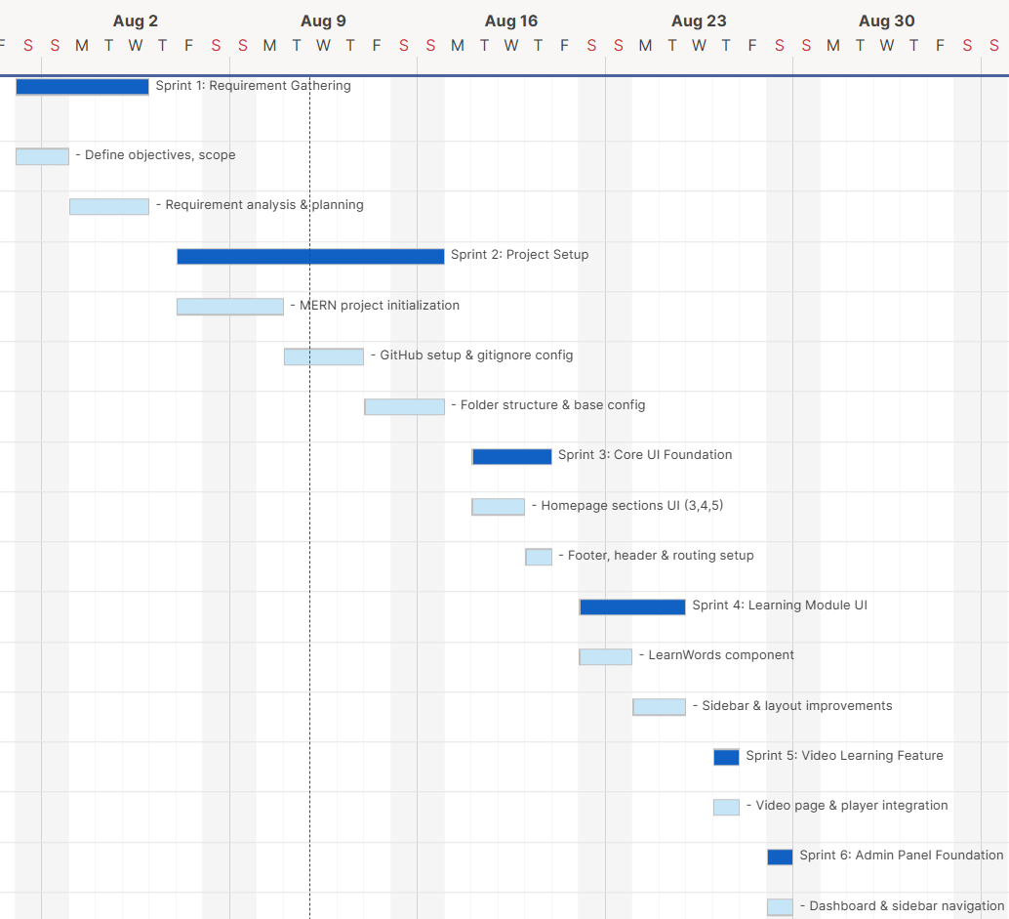
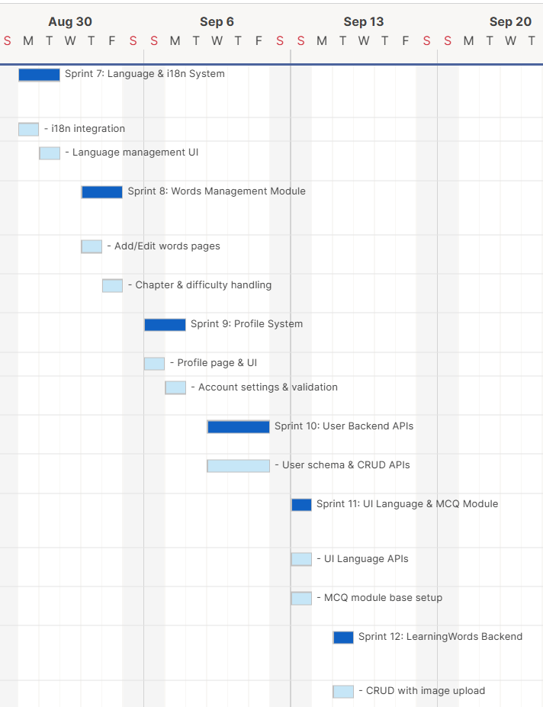
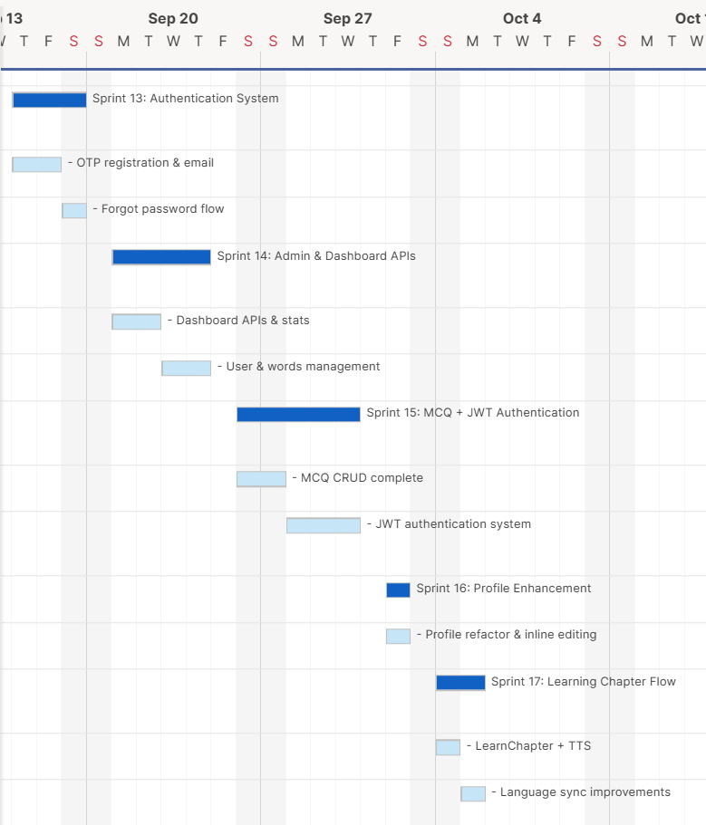
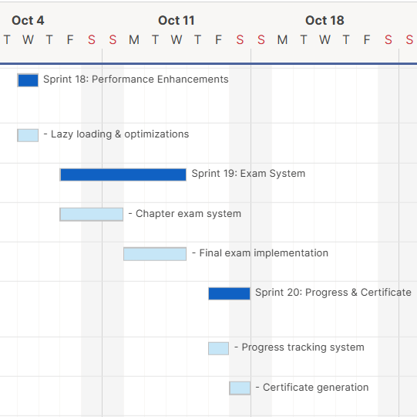
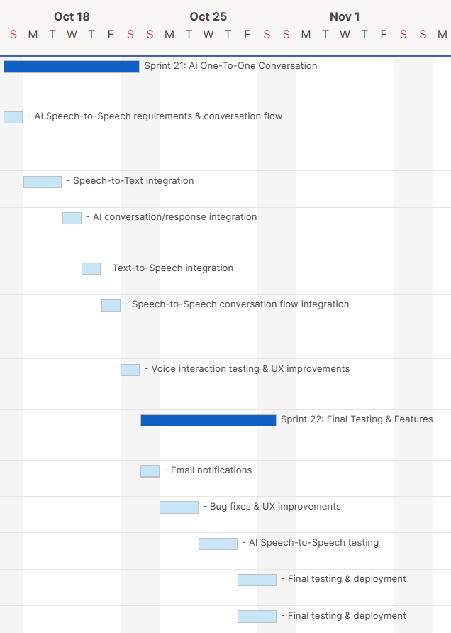

3.6 Sprint Backlog

Task Name | Duration | Start | Finish | Priority | Status
Sprint 1: Requirement Gathering | 5d | 01-08-2026 | 05-08-2026 | High | Complete
- Define objectives, scope | 2d | 01-08-2026 | 02-08-2026 | High | Complete
- Requirement analysis & planning | 3d | 03-08-2026 | 05-08-2026 | High | Complete
Sprint 2: Project Setup | 10d | 07-08-2026 | 16-08-2026 | High | Complete
- MERN project initialization | 4d | 07-08-2026 | 10-08-2026 | High | Complete
- GitHub setup & gitignore config | 3d | 11-08-2026 | 13-08-2026 | High | Complete
- Folder structure & base config | 3d | 14-08-2026 | 16-08-2026 | High | Complete
Sprint 3: Core UI Foundation | 3d | 18-08-2026 | 20-08-2026 | Medium | Complete
- Homepage sections UI (3,4,5) | 2d | 18-08-2026 | 19-08-2026 | Medium | Complete
- Footer, header & routing setup | 1d | 20-08-2026 | 20-08-2026 | Medium | Complete
Sprint 4: Learning Module UI | 4d | 22-08-2026 | 25-08-2026 | Medium | Complete
- LearnWords component | 2d | 22-08-2026 | 23-08-2026 | Medium | Complete
- Sidebar & layout improvements | 2d | 24-08-2026 | 25-08-2026 | Medium | Complete
Sprint 5: Video Learning Feature | 1d | 27-08-2026 | 27-08-2026 | Low | Complete
- Video page & player integration | 1d | 27-08-2026 | 27-08-2026 | Low | Complete
Sprint 6: Admin Panel Foundation | 1d | 29-08-2026 | 29-08-2026 | High | Complete
- Dashboard & sidebar navigation | 1d | 29-08-2026 | 29-08-2026 | High | Complete
Sprint 7: Language & i18n System | 2d | 31-08-2026 | 01-09-2026 | High | Complete
- i18n integration | 1d | 31-08-2026 | 31-08-2026 | High | Complete
- Language management UI | 1d | 01-09-2026 | 01-09-2026 | High | Complete
Sprint 8: Words Management Module | 2d | 03-09-2026 | 04-09-2026 | High | Complete
- Add/Edit words pages | 1d | 03-09-2026 | 03-09-2026 | High | Complete
- Chapter & difficulty handling | 1d | 04-09-2026 | 04-09-2026 | High | Complete
Sprint 9: Profile System | 2d | 06-09-2026 | 07-09-2026 | Medium | Complete
- Profile page & UI | 1d | 06-09-2026 | 06-09-2026 | Medium | Complete
- Account settings & validation | 1d | 07-09-2026 | 07-09-2026 | Medium | Complete
Sprint 10: User Backend APIs | 3d | 09-09-2026 | 11-09-2026 | High | Complete
- User schema & CRUD APIs | 3d | 09-09-2026 | 11-09-2026 | High | Complete
Sprint 11: UI Language & MCQ Module | 1d | 13-09-2026 | 13-09-2026 | High | Complete
- UI Language APIs | 1d | 13-09-2026 | 13-09-2026 | High | Complete
- MCQ module base setup | 1d | 13-09-2026 | 13-09-2026 | High | Complete
Sprint 12: LearningWords Backend | 1d | 15-09-2026 | 15-09-2026 | High | Complete
- CRUD with image upload | 1d | 15-09-2026 | 15-09-2026 | High | Complete
Sprint 13: Authentication System | 3d | 17-09-2026 | 19-09-2026 | High | Complete
- OTP registration & email | 2d | 17-09-2026 | 18-09-2026 | High | Complete
- Forgot password flow | 1d | 19-09-2026 | 19-09-2026 | High | Complete
Sprint 14: Admin & Dashboard APIs | 4d | 21-09-2026 | 24-09-2026 | High | Complete
- Dashboard APIs & stats | 2d | 21-09-2026 | 22-09-2026 | High | Complete
- User & words management | 2d | 23-09-2026 | 24-09-2026 | High | Complete
Sprint 15: MCQ + JWT Authentication | 5d | 26-09-2026 | 30-09-2026 | High | Complete
- MCQ CRUD complete | 2d | 26-09-2026 | 27-09-2026 | High | Complete
- JWT authentication system | 3d | 28-09-2026 | 30-09-2026 | High | Complete
Sprint 16: Profile Enhancement | 1d | 02-10-2026 | 02-10-2026 | Medium | Complete
- Profile refactor & inline editing | 1d | 02-10-2026 | 02-10-2026 | Medium | Complete
Sprint 17: Learning Chapter Flow | 2d | 04-10-2026 | 05-10-2026 | High | Complete
- LearnChapter + TTS | 1d | 04-10-2026 | 04-10-2026 | High | Complete
- Language sync improvements | 1d | 05-10-2026 | 05-10-2026 | High | Complete
Sprint 18: Performance Enhancements | 1d | 07-10-2026 | 07-10-2026 | Low | Complete
- Lazy loading & optimizations | 1d | 07-10-2026 | 07-10-2026 | Low | Complete
Sprint 19: Exam System | 6d | 09-10-2026 | 14-10-2026 | High | Complete
- Chapter exam system | 3d | 09-10-2026 | 11-10-2026 | High | Complete
- Final exam implementation | 3d | 12-10-2026 | 14-10-2026 | High | Complete
Sprint 20: Progress & Certificate | 2d | 16-10-2026 | 17-10-2026 | High | Complete
- Progress tracking system | 1d | 16-10-2026 | 16-10-2026 | High | Complete
- Certificate generation | 1d | 17-10-2026 | 17-10-2026 | High | Complete
Sprint 21: AI One-to-One Conversation | 7d | 18-10-2026 | 24-10-2026 | High | Planned
- AI speech-to-speech requirements & conversation flow | 1d | 18-10-2026 | 18-10-2026 | High | Planned
- Speech-to-Text integration | 2d | 19-10-2026 | 20-10-2026 | High | Planned
- AI conversation/response integration | 1d | 21-10-2026 | 21-10-2026 | High | Planned
- Text-to-Speech integration | 1d | 22-10-2026 | 22-10-2026 | High | Planned
- Speech-to-Speech conversation flow integration | 1d | 23-10-2026 | 23-10-2026 | High | Planned
- Voice interaction testing & UX improvements | 1d | 24-10-2026 | 24-10-2026 | High | Planned
Sprint 22: Final Testing & Deployment | 7d | 25-10-2026 | 31-10-2026 | High | Planned
- Email notifications | 1d | 25-10-2026 | 25-10-2026 | High | Planned
- Bug fixes & UX improvements | 2d | 26-10-2026 | 27-10-2026 | High | Planned
- AI Speech-to-Speech testing | 2d | 28-10-2026 | 29-10-2026 | High | Planned
- Final testing & deployment | 2d | 30-10-2026 | 31-10-2026 | High | Planned

3.7 User Stories

Story-1 (Admin)
User Story Id | As a <User> | Want To <Task> | So that <Goal>
1 | Admin | Login | I can access the admin dashboard and manage the system.
2 | Admin | Manage Users | I can add, update, block, or delete users in the system.
3 | Admin | Manage User Roles | I can assign roles and permissions to users.
4 | Admin | Manage Learning Languages | I can create, update, and delete learning languages and chapters.
5 | Admin | Manage UI Languages | I can control supported interface languages for users.
6 | Admin | Manage Learning Words | I can add, edit, and delete vocabulary and grammar content.
7 | Admin | Manage MCQs | I can create, update, and delete questions for exams.
8 | Admin | View Dashboard | I can monitor system stats like users, languages, and activity.
12 | Admin | Logout | I can securely exit the system and protect data.

Story-2 (User)
User Story Id | As a <User> | Want To <Task> | So that <Goal>
1 | User | Register | I can create an account and access the platform.
2 | User | Login | I can securely access my account and continue learning.
3 | User | Verify OTP | I can confirm my identity during registration or password reset.
4 | User | Select Learning Language | I can choose the language I want to learn.
5 | User | Learn Words & Grammar | I can improve my vocabulary and language understanding.
6 | User | Listen to Pronunciation | I can learn correct pronunciation using text-to-speech.
7 | User | Attempt Chapter Exams | I can test my knowledge after completing a chapter.
8 | User | Track Progress | I can see my learning progress and completed chapters.
9 | User | Attempt Final Exam | I can evaluate my overall knowledge of the language.
10 | User | Get Certificate | I can receive a certificate after successfully completing the course.
11 | User | Update Profile | I can edit my personal details and preferences.
12 | User | Reset Password | I can recover access if I forget my password.
13 | User | Receive Notifications | I can get updates about exams and results via email/SMS.
14 | User | Logout | I can securely exit my account.
15 | User | Start AI One-to-One Conversation | I can practice the language through an interactive AI conversation.
16 | User | Speak to the AI using my voice | I can communicate naturally without typing my responses.
17 | User | Receive an AI voice response | I can listen to the AI's response and continue the conversation.
18 | User | Get AI Speech Feedback | I can identify areas where my pronunciation or speaking can be improved.
19 | User | End AI Conversation | I can safely finish my practice session when I am done.

3.8 Release Plan

Task Name | Duration | Start | Finish | Status | Release Date
Sprint 1: Requirement Gathering | 5d | 01-08-2026 | 05-08-2026 | Complete | 05-08-2026
- Define objectives, scope | 2d | 01-08-2026 | 02-08-2026 | Complete | 02-08-2026
- Requirement analysis & planning | 3d | 03-08-2026 | 05-08-2026 | Complete | 05-08-2026
Sprint 2: Project Setup | 10d | 07-08-2026 | 16-08-2026 | Complete | 16-08-2026
- MERN project initialization | 4d | 07-08-2026 | 10-08-2026 | Complete | 10-08-2026
- GitHub setup & gitignore config | 3d | 11-08-2026 | 13-08-2026 | Complete | 13-08-2026
- Folder structure & base config | 3d | 14-08-2026 | 16-08-2026 | Complete | 16-08-2026
Sprint 3: Core UI Foundation | 3d | 18-08-2026 | 20-08-2026 | Complete | 20-08-2026
- Homepage sections UI (3,4,5) | 2d | 18-08-2026 | 19-08-2026 | Complete | 19-08-2026
- Footer, header & routing setup | 1d | 20-08-2026 | 20-08-2026 | Complete | 20-08-2026
Sprint 4: Learning Module UI | 4d | 22-08-2026 | 25-08-2026 | Complete | 25-08-2026
- LearnWords component | 2d | 22-08-2026 | 23-08-2026 | Complete | 23-08-2026
- Sidebar & layout improvements | 2d | 24-08-2026 | 25-08-2026 | Complete | 25-08-2026
Sprint 5: Video Learning Feature | 1d | 27-08-2026 | 27-08-2026 | Complete | 27-08-2026
- Video page & player integration | 1d | 27-08-2026 | 27-08-2026 | Complete | 27-08-2026
Sprint 6: Admin Panel Foundation | 1d | 29-08-2026 | 29-08-2026 | Complete | 29-08-2026
- Dashboard & sidebar navigation | 1d | 29-08-2026 | 29-08-2026 | Complete | 29-08-2026
Sprint 7: Language & i18n System | 2d | 31-08-2026 | 01-09-2026 | Complete | 01-09-2026
- i18n integration | 1d | 31-08-2026 | 31-08-2026 | Complete | 31-08-2026
- Language management UI | 1d | 01-09-2026 | 01-09-2026 | Complete | 01-09-2026
Sprint 8: Words Management Module | 2d | 03-09-2026 | 04-09-2026 | Complete | 04-09-2026
- Add/Edit words pages | 1d | 03-09-2026 | 03-09-2026 | Complete | 03-09-2026
- Chapter & difficulty handling | 1d | 04-09-2026 | 04-09-2026 | Complete | 04-09-2026
Sprint 9: Profile System | 2d | 06-09-2026 | 07-09-2026 | Complete | 07-09-2026
- Profile page & UI | 1d | 06-09-2026 | 06-09-2026 | Complete | 06-09-2026
- Account settings & validation | 1d | 07-09-2026 | 07-09-2026 | Complete | 07-09-2026
Sprint 10: User Backend APIs | 3d | 09-09-2026 | 11-09-2026 | Complete | 11-09-2026
- User schema & CRUD APIs | 3d | 09-09-2026 | 11-09-2026 | Complete | 11-09-2026
Sprint 11: UI Language & MCQ Module | 1d | 13-09-2026 | 13-09-2026 | Complete | 13-09-2026
- UI Language APIs | 1d | 13-09-2026 | 13-09-2026 | Complete | 13-09-2026
- MCQ module base setup | 1d | 13-09-2026 | 13-09-2026 | Complete | 13-09-2026
Sprint 12: LearningWords Backend | 1d | 15-09-2026 | 15-09-2026 | Complete | 15-09-2026
- CRUD with image upload | 1d | 15-09-2026 | 15-09-2026 | Complete | 15-09-2026
Sprint 13: Authentication System | 3d | 17-09-2026 | 19-09-2026 | Complete | 19-09-2026
- OTP registration & email | 2d | 17-09-2026 | 18-09-2026 | Complete | 18-09-2026
- Forgot password flow | 1d | 19-09-2026 | 19-09-2026 | Complete | 19-09-2026
Sprint 14: Admin & Dashboard APIs | 4d | 21-09-2026 | 24-09-2026 | Complete | 24-09-2026
- Dashboard APIs & stats | 2d | 21-09-2026 | 22-09-2026 | Complete | 22-09-2026
- User & words management | 2d | 23-09-2026 | 24-09-2026 | Complete | 24-09-2026
Sprint 15: MCQ + JWT Authentication | 5d | 26-09-2026 | 30-09-2026 | Complete | 30-09-2026
- MCQ CRUD complete | 2d | 26-09-2026 | 27-09-2026 | Complete | 27-09-2026
- JWT authentication system | 3d | 28-09-2026 | 30-09-2026 | Complete | 30-09-2026
Sprint 16: Profile Enhancement | 1d | 02-10-2026 | 02-10-2026 | Complete | 02-10-2026
- Profile refactor & inline editing | 1d | 02-10-2026 | 02-10-2026 | Complete | 02-10-2026
Sprint 17: Learning Chapter Flow | 2d | 04-10-2026 | 05-10-2026 | Complete | 05-10-2026
- LearnChapter + TTS | 1d | 04-10-2026 | 04-10-2026 | Complete | 04-10-2026
- Language sync improvements | 1d | 05-10-2026 | 05-10-2026 | Complete | 05-10-2026
Sprint 18: Performance Enhancements | 1d | 07-10-2026 | 07-10-2026 | Complete | 07-10-2026
- Lazy loading & optimizations | 1d | 07-10-2026 | 07-10-2026 | Complete | 07-10-2026
Sprint 19: Exam System | 6d | 09-10-2026 | 14-10-2026 | Complete | 14-10-2026
- Chapter exam system | 3d | 09-10-2026 | 11-10-2026 | Complete | 11-10-2026
- Final exam implementation | 3d | 12-10-2026 | 14-10-2026 | Complete | 14-10-2026
Sprint 20: Progress & Certificate | 2d | 16-10-2026 | 17-10-2026 | Complete | 17-10-2026
- Progress tracking system | 1d | 16-10-2026 | 16-10-2026 | Complete | 16-10-2026
- Certificate generation | 1d | 17-10-2026 | 17-10-2026 | Complete | 17-10-2026
Sprint 21: AI One-to-One Conversation | 7d | 18-10-2026 | 24-10-2026 | Planned | 24-10-2026
- AI speech-to-speech requirements & conversation flow | 1d | 18-10-2026 | 18-10-2026 | Planned | 18-10-2026
- Speech-to-Text integration | 2d | 19-10-2026 | 20-10-2026 | Planned | 20-10-2026
- AI conversation/response integration | 1d | 21-10-2026 | 21-10-2026 | Planned | 21-10-2026
- Text-to-Speech integration | 1d | 22-10-2026 | 22-10-2026 | Planned | 22-10-2026
- Speech-to-Speech conversation flow integration | 1d | 23-10-2026 | 23-10-2026 | Planned | 23-10-2026
- Voice interaction testing & UX improvements | 1d | 24-10-2026 | 24-10-2026 | Planned | 24-10-2026
Sprint 22: Final Testing & Deployment | 7d | 25-10-2026 | 31-10-2026 | Planned | 31-10-2026
- Email notifications | 1d | 25-10-2026 | 25-10-2026 | Planned | 25-10-2026
- Bug fixes & UX improvements | 2d | 26-10-2026 | 27-10-2026 | Planned | 27-10-2026
- AI Speech-to-Speech testing | 2d | 28-10-2026 | 29-10-2026 | Planned | 29-10-2026
- Final testing & deployment | 2d | 30-10-2026 | 31-10-2026 | Planned | 31-10-2026

3.9 Risk Register
Risk R-001
Field | Details
Risk ID | R-001
Description | Requirements may change during the development of the project.
Category | Organizational
Root Cause | Changes in project expectations or feature requirements.
Probability / Impact | Medium / High
Risk Score | 6
Risk Owner | Project Manager
Response Strategy | Mitigate
Status | Monitoring
Risk R-002
Field | Details
Risk ID | R-002
Description | Technical issues may delay MERN application development.
Category | Technical
Root Cause | Integration and development issues in frontend, backend, or APIs.
Probability / Impact | Medium / Medium
Risk Score | 4
Risk Owner | Backend Developer / Frontend Developer
Response Strategy | Mitigate
Status | Monitoring

Risk R-003
Field | Details
Risk ID | R-003
Description | Database errors or data loss may affect application functionality.
Category | Technical
Root Cause | Database configuration, integration, or unexpected database failures.
Probability / Impact | Low / High
Risk Score | 3
Risk Owner | Database Integration
Response Strategy | Mitigate
Status | Open
Risk R-004
Field | Details
Risk ID | R-004
Description | Authentication or security vulnerabilities may expose user information.
Category | Technical
Root Cause | Improper authentication, validation, or security implementation.
Probability / Impact | Medium / High
Risk Score | 6
Risk Owner | Backend Developer
Response Strategy | Mitigate
Status | Monitoring

Risk R-005
Field | Details
Risk ID | R-005
Description | AI Speech-to-Speech integration may not perform reliably.
Category | Technical
Root Cause | Integration of Speech-to-Text, AI processing, and Text-to-Speech components.
Probability / Impact | Medium / High
Risk Score | 6
Risk Owner | Backend Developer
Response Strategy | Mitigate
Status | Open
Risk R-006
Field | Details
Risk ID | R-006
Description | AI may incorrectly recognize user speech or accents.
Category | Technical
Root Cause | Variations in pronunciation, accents, background noise, or audio quality.
Probability / Impact | Medium / High
Risk Score | 6
Risk Owner | Backend Developer
Response Strategy | Mitigate
Status | Open

Risk R-007
Field | Details
Risk ID | R-007
Description | AI response generation may be inaccurate or unsuitable for the learning context.
Category | Technical
Root Cause | AI model limitations or inappropriate conversation context.
Probability / Impact | Medium / High
Risk Score | 6
Risk Owner | Backend Developer
Response Strategy | Mitigate
Status | Open
Risk R-008
Field | Details
Risk ID | R-008
Description | Speech processing may introduce high response latency.
Category | Technical
Root Cause | Audio processing, API communication, and AI response generation time.
Probability / Impact | Medium / Medium
Risk Score | 4
Risk Owner | Backend Developer
Response Strategy | Mitigate
Status | Open

Risk R-009
Field | Details
Risk ID | R-009
Description | Testing and bug fixing may take longer than planned.
Category | Operational
Root Cause | Unexpected defects discovered during integration and user acceptance testing.
Probability / Impact | Medium / High
Risk Score | 6
Risk Owner | QA & Testing
Response Strategy | Mitigate
Status | Monitoring
Risk R-010
Field | Details
Risk ID | R-010
Description | Final deployment may be delayed.
Category | Operational
Root Cause | Deployment issues, unresolved defects, or insufficient final testing time.
Probability / Impact | Low / High
Risk Score | 3
Risk Owner | Project Manager
Response Strategy | Mitigate
Status | Open

3.10 Change Request Log
CR ID | Description | Submitted By / Date | Impact Assessment | Decision | Status
CR-001 | Add AI-powered One-to-One Speech-to-Speech Conversation feature. | Project Team / August 2026 | High impact on development, integration, testing, and project schedule. | Approved | Approved
CR-002 | Integrate Speech-to-Text functionality for voice input. | Project Team / August 2026 | Medium impact on backend integration and AI conversation flow. | Approved | Approved
CR-003 | Integrate Text-to-Speech functionality for AI voice responses. | Project Team / August 2026 | Medium impact on AI integration and frontend audio interaction. | Approved | Approved
CR-004 | Add AI-based conversational feedback for language practice. | Project Team / August 2026 | High impact on AI processing and testing requirements. | Approved | Approved

3.11 Status Reports

3.11.1 Status Report – August 2026

Report ID: SR-001
Reporting Period: 01/08/2026 – 31/08/2026
Project Status: Completed
Particular | Details
Project Phase | Project Initiation and Planning
Work Completed | Defined project objectives, scope, functional requirements, and non-functional requirements.
Planning Activities | Prepared the Project Charter, Work Breakdown Structure (WBS), effort estimation, and sprint schedule.
Technical Activities | Initialized the MERN project structure and established the GitHub repository.
Team Activities | Assigned responsibilities among team members for frontend development, backend development, documentation, and testing.
Issues and Risks | Initial requirement analysis and technology selection required coordination among team members.
Next Steps | Begin implementing the core modules, including authentication, language management, and learning functionality.

3.11.2 Status Report – September 2026

Report ID: SR-002
Reporting Period: 01/09/2026 – 30/09/2026
Project Status: Development in Progress

Particular | Details
Project Phase | System Development and Integration
Work Completed | Development of the core language-learning modules and supporting application functionality progressed according to the project requirements.
Frontend Development | Implemented React-based interfaces for learning activities, assessments, and user interaction.
Backend Development | Developed Node.js and Express.js APIs to support application functionality and data processing.
Database Integration | Integrated MongoDB for storing and retrieving application data.
Additional Activities | Worked on authentication, language learning content, chapter management, MCQs, examinations, and progress tracking.
Issues and Risks | API integration, data consistency, and coordination between frontend and backend components required attention.
Next Steps | Continue integration, optimize application performance, test implemented modules, and address identified defects.

3.11.3 Status Report – October 2026

Report ID: SR-003
Reporting Period: 01/10/2026 – 31/10/2026
Project Status: Finalization and Documentation in Progress
Particular | Details
Project Phase | Testing, Optimization, and Documentation
Work Completed | Continued refinement of the application, review of existing functionality, and preparation of project documentation.
Performance Optimization | Improved chapter-loading performance through API response caching, concurrent API requests, and separation of API logic into service layers.
Design Pattern Implementation | Applied design patterns, including the Facade and Proxy patterns, to improve code organization and API response handling.
AI Voice Conversation | Worked on AI-powered speech-to-speech conversation functionality using speech-to-text, AI response generation, and text-to-speech.
Conversation History | Planned MongoDB-based conversation history storage and performance evaluation after a conversation ends.
Issues and Risks | API errors, integration issues, and performance considerations required further investigation and testing.
Next Steps | Complete remaining development tasks, conduct functional and integration testing, resolve defects, finalize documentation, and prepare the project demonstration.

System Design

4.1 System Architecture

4.1.1 Overview
The VOCO – Native Language Learning Platform follows a Layered Architecture based on the MERN technology stack. This architecture organizes the application into separate layers, each responsible for specific operations. It improves code organization, maintainability, and separation of concerns.
The system is developed using React.js for the frontend, Node.js and Express.js for backend operations, and MongoDB for data storage. It also integrates AI-powered voice processing to support interactive language practice.

The architecture consists of the following components:
- Presentation Layer
- Application Layer
- Data Access Layer
- Database Layer
- AI and Voice Processing Services

4.1.2 Components of System Architecture

Presentation Layer
The presentation layer is the user-facing part of the application, developed using React.js, HTML, CSS, and JavaScript. It allows learners and administrators to interact with the platform through a web browser.
Responsibilities:
- User authentication and profile management.
- Displaying languages, chapters, vocabulary, and MCQs.
- Conducting examinations and displaying learning progress.
- Providing dashboard, administrative, and AI voice conversation interfaces.

Application Layer
The application layer is developed using Node.js and Express.js. It processes requests from the presentation layer, executes application logic, and coordinates communication with the database and supporting services.
Responsibilities:
- Managing users, languages, chapters, and learning content.
- Processing vocabulary, MCQ, and examination operations.
- Managing user progress and administrative operations.
- Coordinating AI conversation and voice-processing requests.

Data Access Layer
The data access layer manages communication between the application logic and MongoDB. It uses the application's database models and queries to retrieve, insert, update, and delete data.
Responsibilities:
- Accessing user, profile, language, and chapter data.
- Managing vocabulary and MCQ records.
- Storing examination attempts and user progress.
- Performing database operations required by application features.

Database Layer
MongoDB is the database management system used by VOCO. It stores and manages the information required for the platform's learning and administrative functionalities.
Responsibilities:
- Storing user accounts and profile information.
- Maintaining interface languages, learning languages, and chapters.
- Storing vocabulary and MCQ data.
- Maintaining examination attempts and learning progress.
- Storing conversation history if implemented.

AI and Voice Processing Services
The AI and voice-processing components extend the platform by enabling interactive spoken conversations between learners and an AI conversation partner.
The voice conversation process involves the following operations:
- Speech-to-Text (STT): Converts spoken input into text.
- AI Conversation Processing: Generates responses based on recognized text.
- Text-to-Speech (TTS): Converts AI-generated responses into audio.
- Audio Playback: Returns generated audio to the frontend for playback.
- Conversation Evaluation: Analyzes conversation data and provides feedback if implemented.

4.1.3 System Architecture Diagram
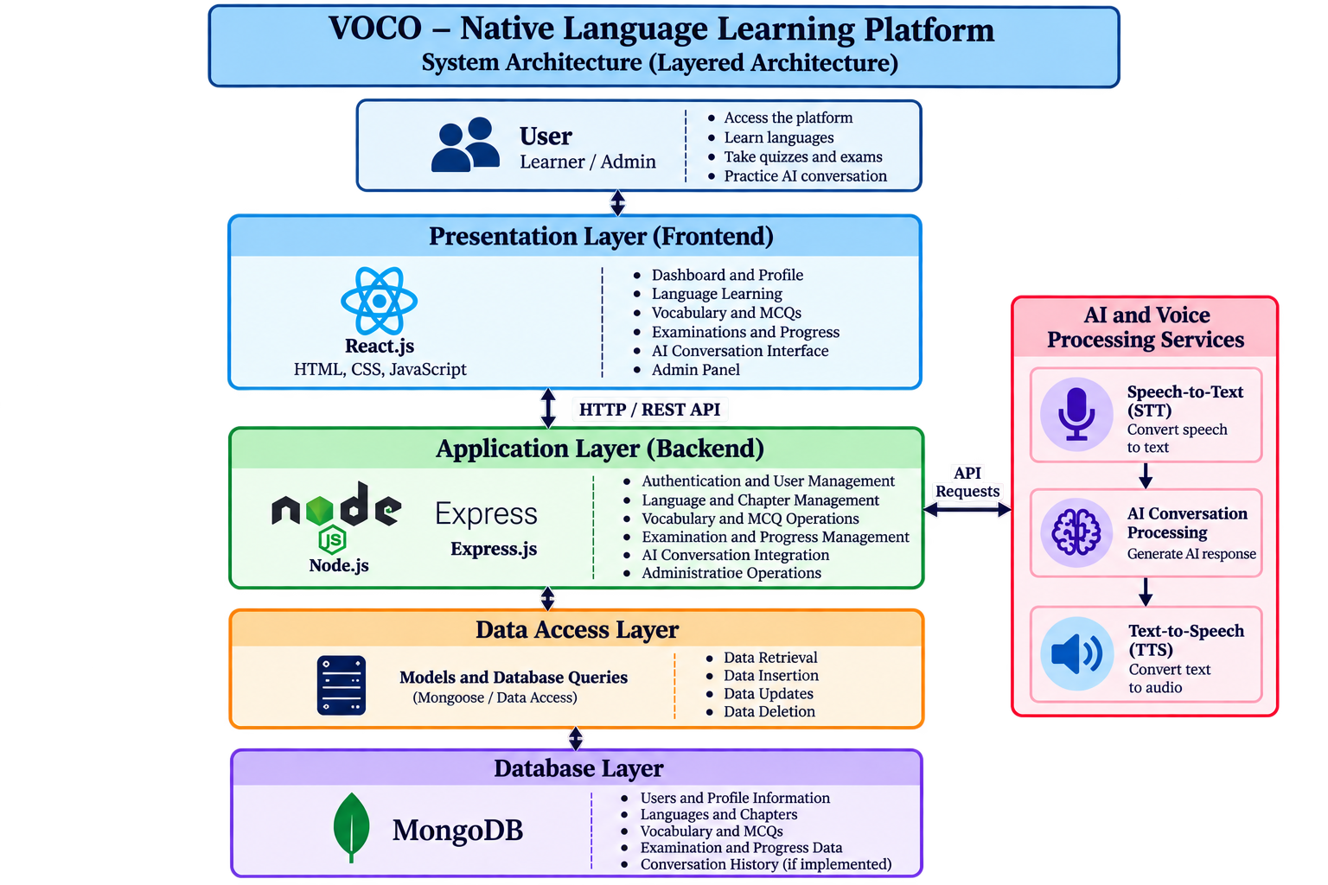

4.1.4 Working of the System

- The user accesses the platform through the React.js frontend.
- The user performs an operation, such as logging in, selecting a language, completing a quiz, or checking learning progress.
- The frontend sends the appropriate HTTP request to the Node.js and Express.js backend.
- The application layer processes the request and executes the required business logic.
- When database operations are required, the data access layer communicates with MongoDB to retrieve or update the relevant information.
- The backend returns the result to the frontend, which displays the information to the user.
- For AI-powered voice conversations, the system processes the user's speech, generates an AI response, converts the response into audio, and plays it through the frontend.
- Learning progress and examination results are maintained in the database to support progress monitoring and performance reporting.

4.2 Module Description
The VOCO – Native Language Learning Platform is divided into several modules, each responsible for specific functionalities of the system. The modules work together to provide an integrated platform for language learning, vocabulary practice, examinations, progress tracking, and AI-based voice conversations. The system is developed using React.js for the frontend, Node.js and Express.js for the backend, and MongoDB for data storage.

4.2.1 User Authentication and Profile Management Module
- Manages user registration, login, authentication, and profile information.
- Supports profile picture management and user roles (User/Admin).

4.2.2 Language and Chapter Management Module
- Displays available learning languages and their associated chapters.
- Organizes learning content and supports translated chapter information.

4.2.3 Vocabulary Learning Module
- Provides vocabulary words organized by chapters and difficulty levels.
- Supports grammar learning and vocabulary practice.

4.2.4 Multiple-Choice Questions (MCQ) Module
- Provides chapter-based MCQs with multiple answer options.
- Evaluates answers using the correct-answer information.

4.2.5 Examination and Progress Tracking Module
- Supports chapter-based and final examinations and records examination attempts.
- Tracks completed chapters and overall course completion.

4.2.6 AI-Based Voice Conversation Module
- Enables users to practise conversations using Speech-to-Text (STT), AI processing, and Text-to-Speech (TTS).
- Allows users to interact with the AI through voice-based conversations.

4.2.7 Conversation History and Performance Evaluation Module
- Maintains conversation records for reviewing user-AI interactions.
- Evaluates conversation performance and provides feedback after a session.

4.2.8 Dashboard Module
- Displays a summary of learning activities and user progress.
- Provides access to important learning and assessment features.

4.2.9 Administrative Management Module
- Supports the management of learning languages, chapters, vocabulary, and MCQs.
- Provides administrative access according to user roles.

4.2.10 User Interface Language Management Module
- Maintains supported interface languages, language codes, and language names.
- Supports interface localization through active language settings.

4.2.11 Database Management Module
- Uses MongoDB and Mongoose to store and retrieve application data.
- Manages user, language, chapter, vocabulary, examination, and progress information.

4.3 Use Case Diagram
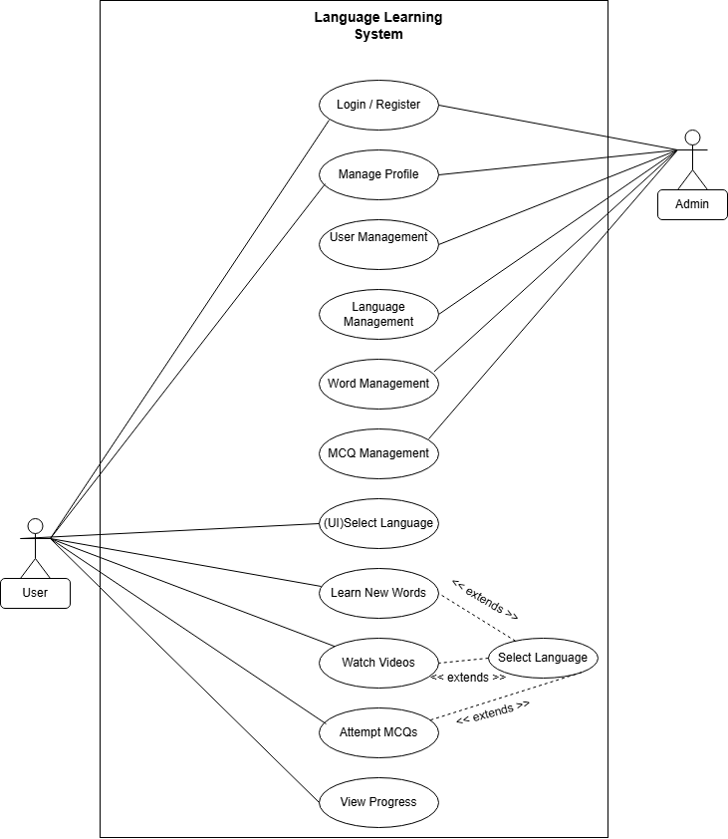

4.4 Class Diagram
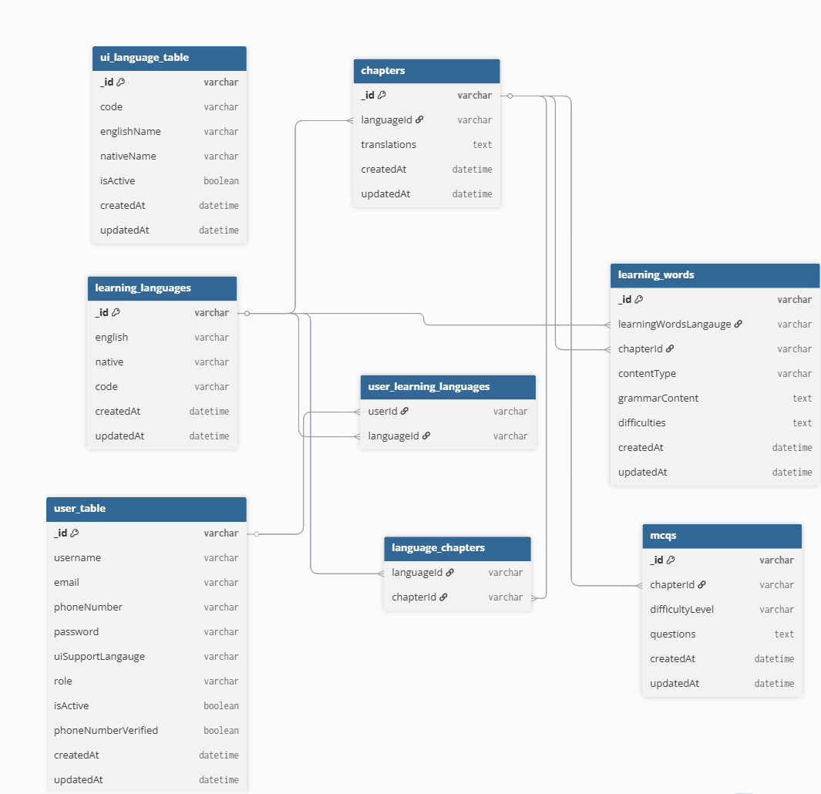

4.5 Interaction Diagram

1. User Registration & Login
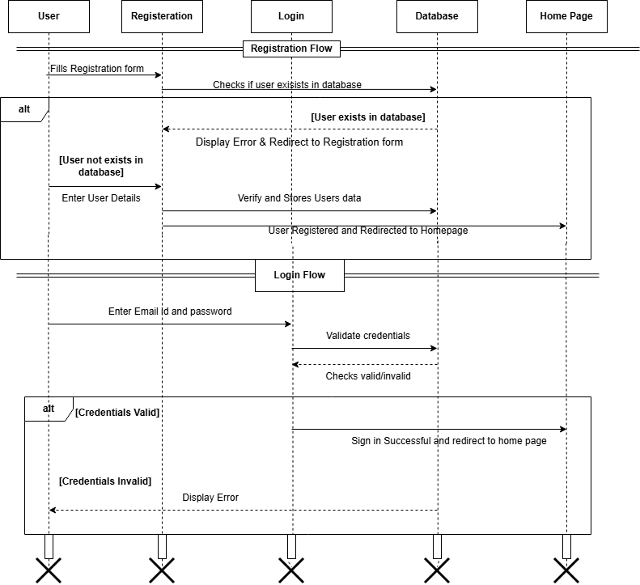

Learning Language
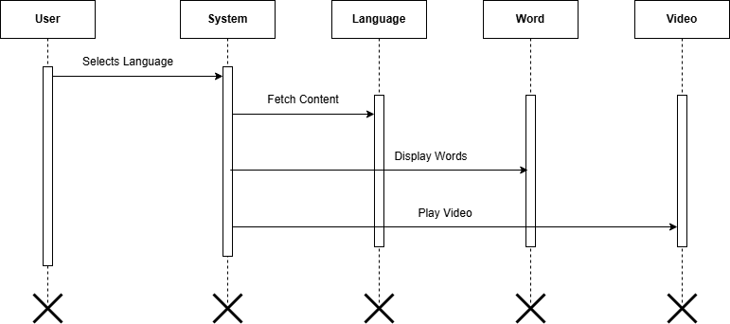

Admin Management
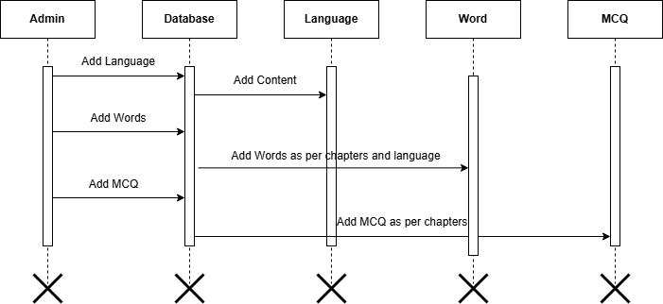

4.6 Activity Diagram

1. User
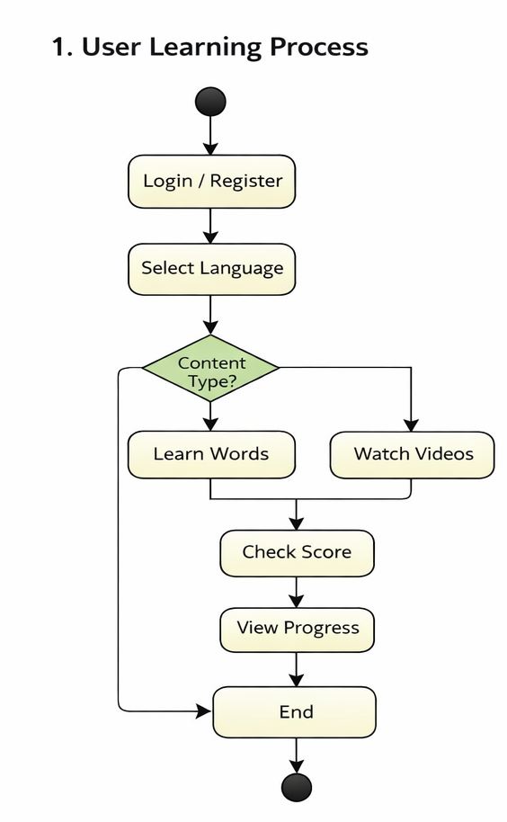

2. Admin
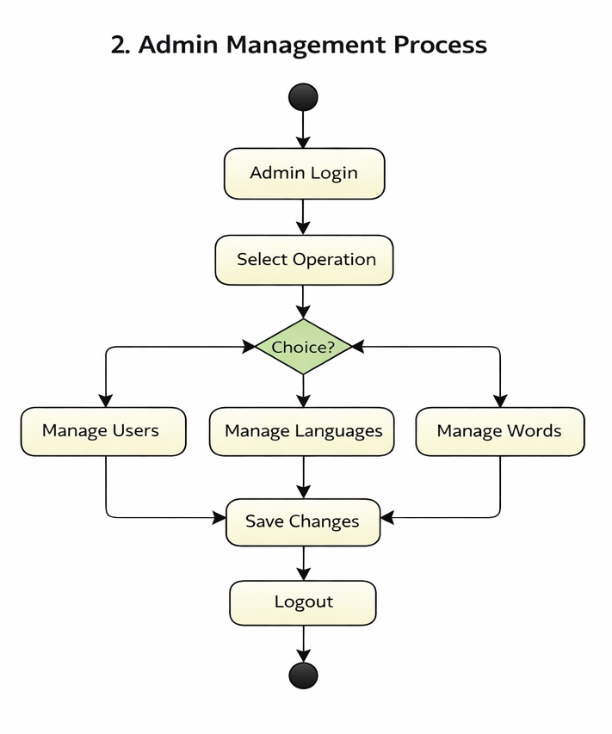

3. MCQs
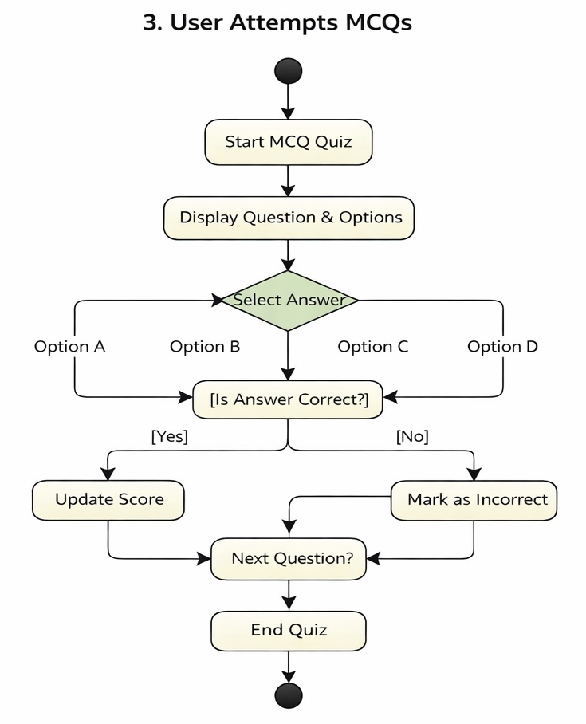

4.7 Data Dictionary

Total number of tables required: 8
Sr. No | Table Name | Table Description
1 | user_tables | Stores user account information. Each document contains user details such as username, email, password, role, and learning preferences.
2 | learning_languages | Stores information about available learning languages and their associated chapters.
3 | chapters | Stores chapters for each language with multilingual titles.
4 | learningwords | Stores vocabulary and grammar content for each chapter with difficulty levels.
5 | MCQ | Stores multiple-choice questions for chapter-based and final exams.
6 | ExamAttempt | Stores user exam attempts for both chapter and final exams.
7 | ui_language_tables | Stores UI language translations used in the application interface.  Each document contains text labels for different languages used in the frontend.
8 | UserProgress | Tracks user learning progress, completed chapters, and course completion status.

1. Table Name: user_tables
Table Description: Stores user account information. Each document contains user details such as username, email, password, role, and learning preferences.
Field Name | Data Type | Constraint | Description
_id | ObjectId | Primary Key | Unique identifier for each user
username | String | Required | Username
email | String | Required, Unique | User email
phoneNumber | String | Required, Unique | Phone number
password | String | Required | User password
uiSupportLangauge | String | Default: English | UI language preference
learningLanguages | ObjectId [] | Ref: learning_languages | Selected learning languages
role | String | Default: user | User role (user/admin)
isActive | Boolean | Default: true | Active or inactive user
phoneNumberVerified | Boolean | Default: false | Phone verification status
emailNotifications | Boolean | Default: false | Activate or Deactivate Notification Sending
reminderTime | String | Default: null | Display Reminder Time
createdAt | Date | Auto | Record creation time
updatedAt | Date | Auto | Record update time

2. Table Name: learning_languages
Table Description: Stores information about available learning languages and their associated chapters.
Field Name | Data Type | Constraint | Description
_id | ObjectId | Primary Key | Unique identifier
english | String | Required | Language name in English
native | String | Required | Language name in native form
code | String | Required | Language code (e.g., en, hi)
chapters | ObjectId [] | Ref: chapters | Related chapters
createdAt | Date | Auto | Creation time

3. Table Name: chapters
Table Description: Stores chapters for each language with multilingual titles.
Field Name | Data Type | Constraint | Description
_id | ObjectId | Primary Key | Unique identifier
languageId | ObjectId | Ref: learning_languages, Required | Related language
translations | Map<String> | - | Chapter names in multiple languages
createdAt | Date | Auto | Creation time
updatedAt | Date | Auto | Update time

4. Table Name: LearningWords
Table Description: Stores vocabulary and grammar content for each chapter with difficulty levels.
Field Name | Data Type | Constraint | Description
_id | ObjectId | Primary Key | Unique identifier
learningWordsLangauge | ObjectId | Ref: learning_languages, Required | Language reference
chapterId | ObjectId | Ref: chapters, Required | Chapter reference
contentType | String | Required | Type (word/grammar)
grammarContent | Map<String> | Default {} | Multi-language grammar content
difficulties | Array | Required | Difficulty levels
difficulties. level | String | Required | Difficulty level
difficulties. words | Map [] | Required | Words data
createdAt | Date | Auto | Creation time
updatedAt | Date | Auto | Update time

5. Table Name: MCQs
Table Description: Stores multiple-choice questions for chapter-based and final exams.
Field Name | Data Type | Constraint | Description
_id | ObjectId | Primary Key | Unique identifier
chapterIds | ObjectId [] | Ref: chapters, Required | Related chapters
difficultyLevel | String | Required | Difficulty level
questions | Array | Required | List of questions
questions. question | Map | Required | Question in multiple languages
questions. options | Map [] | Required | Options list
questions. correctAnswer | Number | Required | Correct option index
createdAt | Date | Auto | Creation time
updatedAt | Date | Auto | Update time

6. Table Name: ExamAttempt
Table Description: Stores user exam attempts for both chapter and final exams.
Field Name | Data Type | Constraint | Description
_id | ObjectId | Primary Key | Unique identifier
userId | ObjectId | Required | User reference
chapterId | ObjectId | Optional | Chapter exam reference
langId | ObjectId | Optional | Final exam language reference
examType | String | Required | Type (chapter/final)
mcqIds | ObjectId [] | Ref: MCQs | MCQ references
answers | Array | - | User answers
answers. mcqId | ObjectId | - | MCQ reference
answers. questionIndex | Number | - | Question index
answers. selectedOption | Number | - | Selected option
startTime | Date | - | Exam start time
endTime | Date | - | Exam end time
isCompleted | Boolean | Default false | Completion status
createdAt | Date | Auto | Creation time
updatedAt | Date | Auto | Update time

7. Table Name: ui_languge_table
Table Description: Stores supported UI languages for the platform.
Field Name | Data Type | Constraint | Description
_id | ObjectId | Primary Key | Unique identifier
code | String | Unique | Language code
englishName | String | - | Language name in English
nativeName | String | - | Language name in native
isActive | Boolean | Default true | Active status
createdAt | Date | Auto | Creation time
updatedAt | Date | Auto | Update time

8. Table Name: UserProgress
Table Description: Tracks user learning progress, completed chapters, and course completion status.
Field Name | Data Type | Constraint | Description
_id | ObjectId | Primary Key | Unique identifier
userId | ObjectId | Ref: user_table, Unique | User reference
learningLanguages | Array | Required | Language progress
learningLanguages.languageId | ObjectId | Ref: learning_languages | Language reference
learningLanguages.completedChapters | ObjectId [] | Ref: chapters | Completed chapters
learningLanguages.isCourseCompleted | Boolean | Default false | Completion status
learningLanguages.completedAt | Date | Default null | Completion date
createdAt | Date | Auto | Creation time
updatedAt | Date | Auto | Update time

Development

5.1 Coding Standards

Coding standards are rules that help us write clean, readable, and organized code. In VOCO, we follow these standards to make the project easier to understand, maintain, and update.
Standards Followed
- Meaningful Names: Use names that clearly explain the purpose of variables, functions, and components.
- Code Reusability: Reuse existing code instead of writing the same code multiple times.
- Proper Code Structure: Divide the project into components, controllers, routes, models, and services.
- Error Handling: Handle errors properly so the application can respond appropriately when something goes wrong.
- Code Comments: Add comments to explain complex parts of the code.
- Database Management: Use Mongoose models to organize and manage MongoDB data.
- Security: Protect user information and validate user input.

5.2 SOLID Principles & Refactoring

SOLID principles are five basic rules that help developers write better software. Refactoring means improving the internal structure of existing code without changing its functionality.
- Single Responsibility Principle (SRP)
Meaning: One class, component, or module should have one main responsibility.
Example in VOCO: React components handle the user interface, controllers handle API requests, and models manage database structures.

- Open/Closed Principle (OCP)
Meaning: We should be able to add new features without making unnecessary changes to existing code.
Example in VOCO: We can add a new learning feature as a separate module without rewriting the entire application.

- Liskov Substitution Principle (LSP)
Meaning: One implementation should be replaceable with another compatible implementation without breaking the application.
Example in VOCO: We could replace one speech-processing service with another compatible service while keeping the same expected inputs and outputs.

- Interface Segregation Principle (ISP)
Meaning: A module should only need the functions that are relevant to its work.
Example in VOCO: User management, vocabulary learning, and examinations have separate API operations for their specific tasks.

- Dependency Inversion Principle (DIP)
Meaning: Important business logic should not depend too closely on specific technical implementations.
Example in VOCO: Separating AI service logic from other application logic makes it easier to change the AI service in the future.

Design Pattern Implementation & Documentation

6.1 Pattern Selection & Justification
In the VOCO project, different design patterns are used to make the code easier to manage, reuse, and maintain. Each pattern is selected according to the requirement of the module.
The following design patterns and techniques are used in the project:
- Singleton Pattern: Used in apiClient.js to provide a shared Axios instance for API requests.
- Factory Pattern: Used in ExamAttemptFactory.js to create exam attempt objects.
- Facade Pattern: Used in LearnChapterFacade.js to simplify the process of fetching chapter and progress data.
- Strategy Pattern: Used in LearningWordsController.js to handle different types of learning content, such as TextBlock and TextArea.
- Proxy Pattern: Used in ApiCache.js to check cached API data before making repeated requests.
- Service Layer: Used to separate API-related operations from React components.
These patterns help reduce code duplication, improve code organization, and make future updates easier.

6.2 Creational Pattern

Singleton Pattern
Purpose: To provide one shared instance of a component that can be reused throughout the application.
Implementation in VOCO: The apiClient.js file creates and exports a shared Axios instance for making API requests.
Justification: Instead of creating separate Axios instances in different parts of the application, the project can reuse the same configured instance. This helps maintain consistent API settings and reduces repeated configuration.
Factory Pattern
Purpose: To create objects through a dedicated function instead of writing object-creation logic repeatedly.
Implementation in VOCO: The Factory Pattern is used in ExamAttemptFactory.js. The ExamAttemptController.js imports and calls the createExamAttempt function to create exam attempt objects.
Justification: It keeps exam attempt creation in a separate place, making the controller easier to understand and helping maintain consistent object creation.

6.3 Structural Pattern

Facade Pattern
Purpose: To provide a simple interface for working with multiple operations or components.
Implementation in VOCO: The LearnChapterFacade.js file coordinates requests for chapter data and user progress data.
Justification: The React component does not need to manage every request separately. The Facade handles the related operations and simplifies how the component retrieves the required data.
Proxy Pattern
Purpose: To act as an intermediary between the application and the resource being accessed.
Implementation in VOCO: The ApiCache.js file manages cached API responses. It checks whether suitable data is already available in the cache before requiring another request. The cache also supports expiration and invalidation.
Justification: Reusing cached responses can reduce unnecessary API requests and improve performance. Cache expiration and invalidation help prevent outdated data from being used for too long.

6.4 Behavioral Pattern

Strategy Pattern
Purpose: To select a suitable processing method according to the type of data being handled.
Implementation in VOCO: The LearningWordsController.js uses different strategies for processing TextBlock and TextArea content. It defines textBlockStrategy, textAreaStrategy, and a getContentStrategy function to select the appropriate strategy.
Justification: Different content types may require different processing rules. The Strategy Pattern keeps these rules separate and makes it easier to add or modify content-processing methods without placing all the logic in one block.

6.5 UML Mapping (Pattern-to-Class Diagram Traceability)

UML class diagrams help explain the relationship between classes, controllers, services, and other components where design patterns are implemented. In the VOCO project, the following mapping shows how each design pattern is connected to the corresponding files.
Pattern-to-Class Mapping
Design Pattern | Related Class/File | Purpose
Singleton Pattern | apiClient.js | Provides a shared Axios instance for API requests.
Factory Pattern | ExamAttemptFactory.js, ExamAttemptController.js | Creates exam attempt objects through a factory function.
Facade Pattern | LearnChapterFacade.js, LearnChapter.js | Coordinates chapter and progress data requests.
Proxy Pattern | ApiCache.js | Checks cached data and supports cache expiration and invalidation.
Strategy Pattern | LearningWordsController.js | Selects a suitable strategy for processing TextBlock and TextArea content.
Service Layer | LearningWordsService.js, UserProgressService.js | Separates API operations from UI components.

UML Relationships
The main relationships between these components can be described as follows:
- Singleton Pattern: React components and service modules can reuse the shared Axios instance exported by apiClient.js.
- Factory Pattern: ExamAttemptController.js calls the createExamAttempt function from ExamAttemptFactory.js to create exam attempt objects.
- Facade Pattern: LearnChapter.js uses LearnChapterFacade.js to coordinate the retrieval of chapter and progress data.
- Proxy Pattern: ApiCache.js provides caching functionality to reduce repeated API requests when cached data is available.
- Strategy Pattern: LearningWordsController.js selects the appropriate content-processing strategy based on the content type.
- Service Layer: LearningWordsService.js and UserProgressService.js handle API-related operations separately from the React components.

6.6 Documentation & Trade-off Analysis

Documentation
Documentation is important because it explains how the design patterns are implemented and why they are used in the VOCO project.

The following practices support code understanding and maintenance:
- Code Comments: Comments explain the purpose of important modules and design patterns.
- Meaningful Names: Files and functions use names such as LearnChapterFacade.js and createExamAttempt, making their responsibilities easier to understand.
- Separation of Responsibilities: Controllers, services, and React components handle different parts of the application.
- Reusable Components: Shared modules such as apiClient.js help avoid repeated configuration.
- Caching Documentation: ApiCache.js supports cache expiration and invalidation to help manage cached data.
- Maintainability: The code structure makes it easier to identify the relevant module when a feature needs modification.

Trade-off Analysis
Every design pattern has advantages and disadvantages. The following table summarizes the main trade-offs in the VOCO project.
Design Pattern | Advantages | Trade-offs
Singleton Pattern | Reuses a shared Axios instance and avoids repeated configuration. | Changes to shared configuration may affect multiple API requests.
Factory Pattern | Centralizes exam attempt object creation and improves consistency. | Adds a separate factory module that must be maintained.
Facade Pattern | Simplifies data retrieval and coordinates related API requests. | Adds an extra layer that must be updated when the underlying services change.
Proxy Pattern | Reduces repeated API requests and can improve response time. | Cached data may become outdated if expiration and invalidation are not handled properly.
Strategy Pattern | Separates content-processing logic for different content types. | Requires additional functions and selection logic for the different strategies.
Service Layer | Separates API operations from UI components and improves code organization. | Adds more files and requires clear coordination between components and services.

6.7 Testing

Test Case ID | 101 | Test Case Name | User Registration
Project Name | VOCO - Native Language Learning Platform | Browser | Google Chrome
Written By | Yash Shah | Description | User registration page where new users create an account using email, password, and OTP verification.
Tested By | Meet Patel | Tested On | 18-03-2026
Test # | Test Data | Expected Result | Actual Result | Status
1 | Valid email, password, username | User successfully registered | User successfully registered | Pass
2 | Duplicate email | Error: "User already exists" | Error displayed correctly | Pass
3 | Weak password (<8 chars) | Error: "Password must be strong" | Error displayed | Pass
4 | Invalid email format | Error: "Invalid email" | Error displayed | Pass
5 | Valid data but OTP not entered | Registration blocked | User blocked | Pass
6 | Duplicate phone/email | Registration fails | User registered | Fail

Test Case ID | 102 | Test Case Name | User Login
Project Name | VOCO - Native Language Learning Platform | Browser | Google Chrome
Written By | Meet Patel | Description | User login using email and password with JWT authentication.
Tested By | Krishna Radhani | Tested On | 20-03-2026
Test # | Test Data | Expected Result | Actual Result | Status
1 | Valid email & password | Login successful | Login successful | Pass
2 | Wrong password | Error: "Invalid credentials" | Error shown | Pass
3 | Non-existing email | Error: "User not found" | Error shown | Pass
4 | Empty fields | Validation error | Validation error | Pass
5 | Token expired | Auto logout | logged out | Pass

Test Case ID | 103 | Test Case Name | Learning Words Module
Project Name | VOCO - Native Language Learning Platform | Browser | Google Chrome
Written By | Krishna Radhani | Description | User can view, and Admin can add, and interact with learning words.
Tested By | Yash Shah | Tested On | 15-03-2026
Test # | Test Step | Action | Expected Result | Actual Result | Status
1 | Open LearnWords page | Click module | Words displayed | Words displayed | Pass
2 | Select language | Choose language | Filtered words shown | Works correctly | Pass
3 | Play pronunciation | Click speaker icon | Audio plays | Audio plays | Pass
4 | Invalid word data | Load page | Handle error | Page crashes | Fail

Test Case ID | 104 | Test Case Name | MCQ Module
Project Name | VOCO - Native Language Learning Platform | Browser | Google Chrome
Written By | Meet Patel | Description | Admin can add/edit MCQs and users can attempt them.
Tested By | Yash Shah | Tested On | 26-03-2026
Test # | Test Step | Action | Expected Result | Actual Result | Status
1 | Add MCQ | Fill valid data | MCQ added | MCQ added | Pass
2 | Edit MCQ | Update question | MCQ updated | MCQ updated | Pass
3 | Delete MCQ | Remove MCQ | Deleted | Deleted | Pass
4 | Invalid input | Submit empty fields | Error shown | Error shown | Pass

Test Case ID | 105 | Test Case Name | Chapter Exam
Project Name | VOCO - Native Language Learning Platform | Browser | Google Chrome
Written By | Yash Shah | Description | User attempts chapter-wise MCQ exam.
Tested By | Meet Patel | Tested On | 05-04-2026
Test # | Test Step | Action | Expected Result | Actual Result | Status
1 | Add MCQ | Fill valid data | MCQ added | MCQ added | Pass
2 | Edit MCQ | Update question | MCQ updated | MCQ updated | Pass
3 | Delete MCQ | Remove MCQ | Deleted | Deleted | Pass
4 | Invalid input | Submit empty fields | Error shown | No shown | Pass

Test Case ID | 106 | Test Case Name | Final Exam
Project Name | VOCO - Native Language Learning Platform | Browser | Google Chrome
Written By | Meet Patel | Description | User attempts final exam after completing all chapters.
Tested By | Krishna Radhani | Tested On | 09-04-2026
Test # | Test Step | Action | Expected Result | Actual Result | Status
1 | Start final exam | Click start | Exam opens | Opens | Pass
2 | Without completing chapters | Access exam | Access denied | Allowed | Fail
3 | Submit exam | Complete exam | Score generated | Generated | Pass

6.8 Project Tracking & Monitoring

6.9 Screenshots

- Home Page

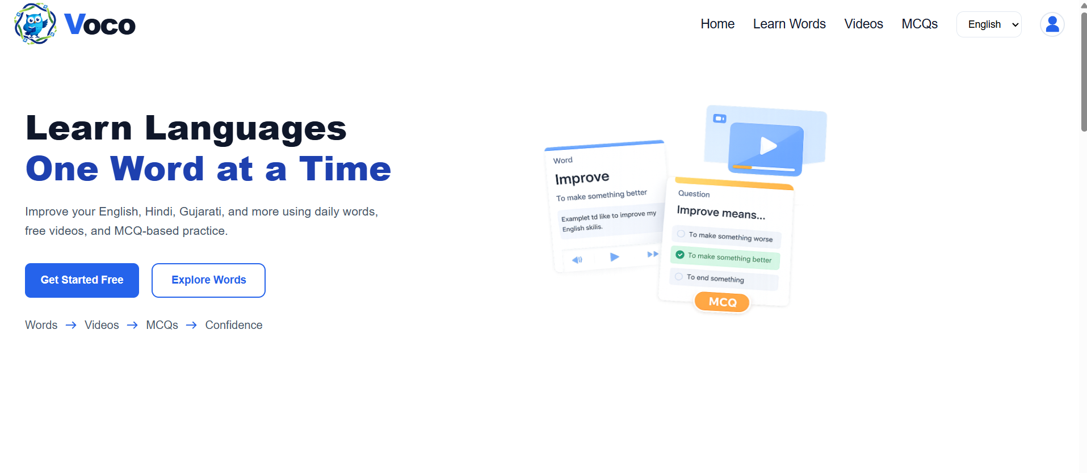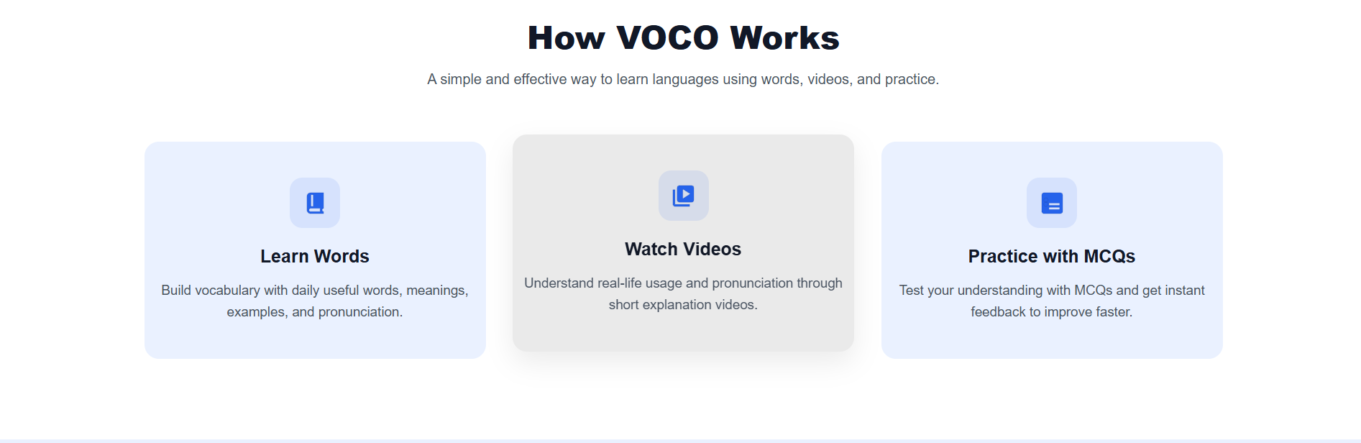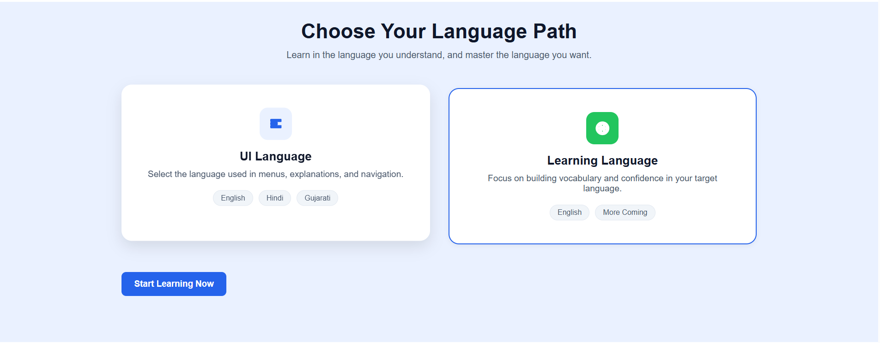
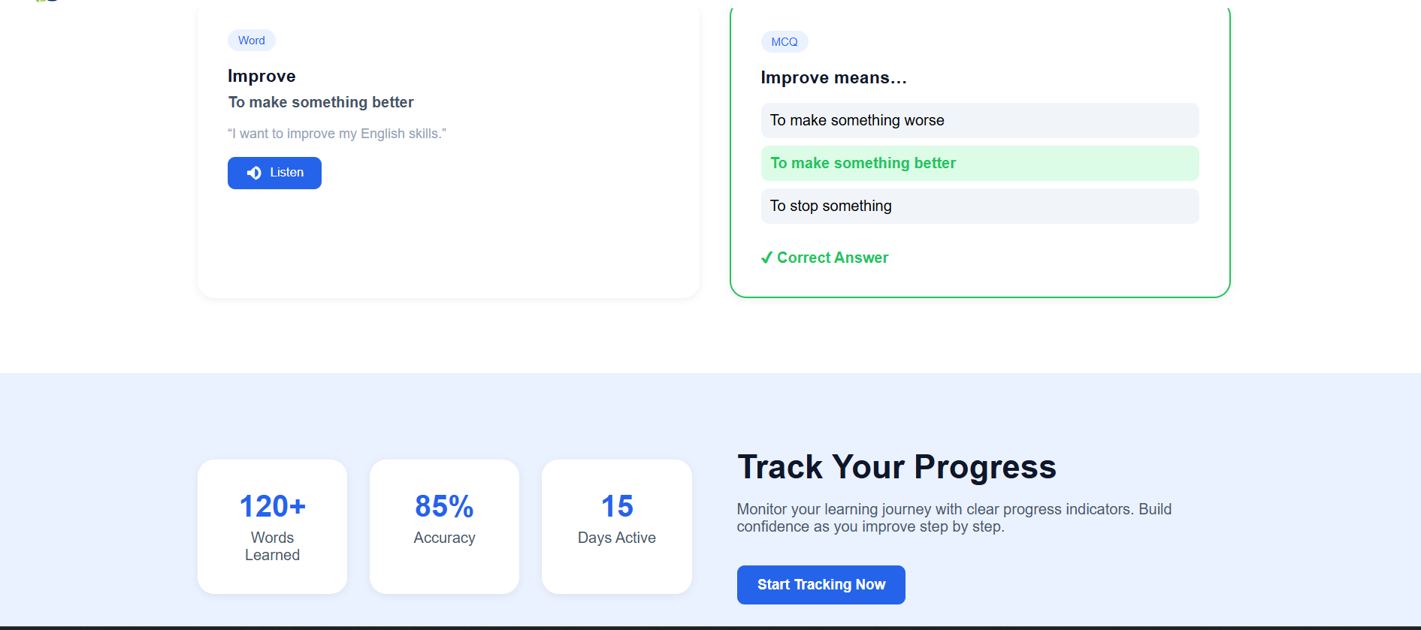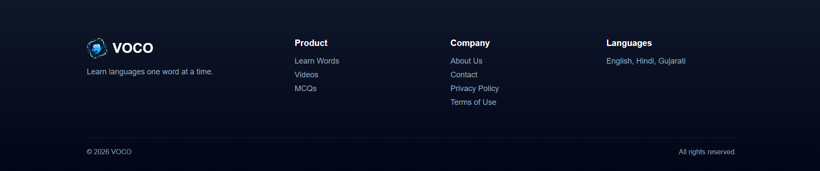

- SignIn
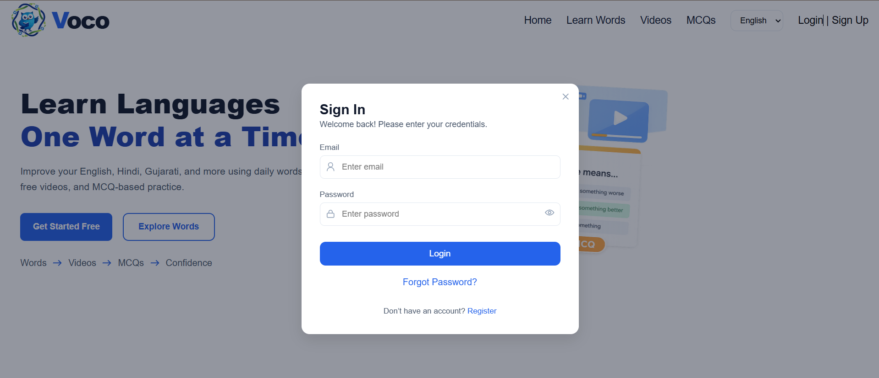
- SignUp

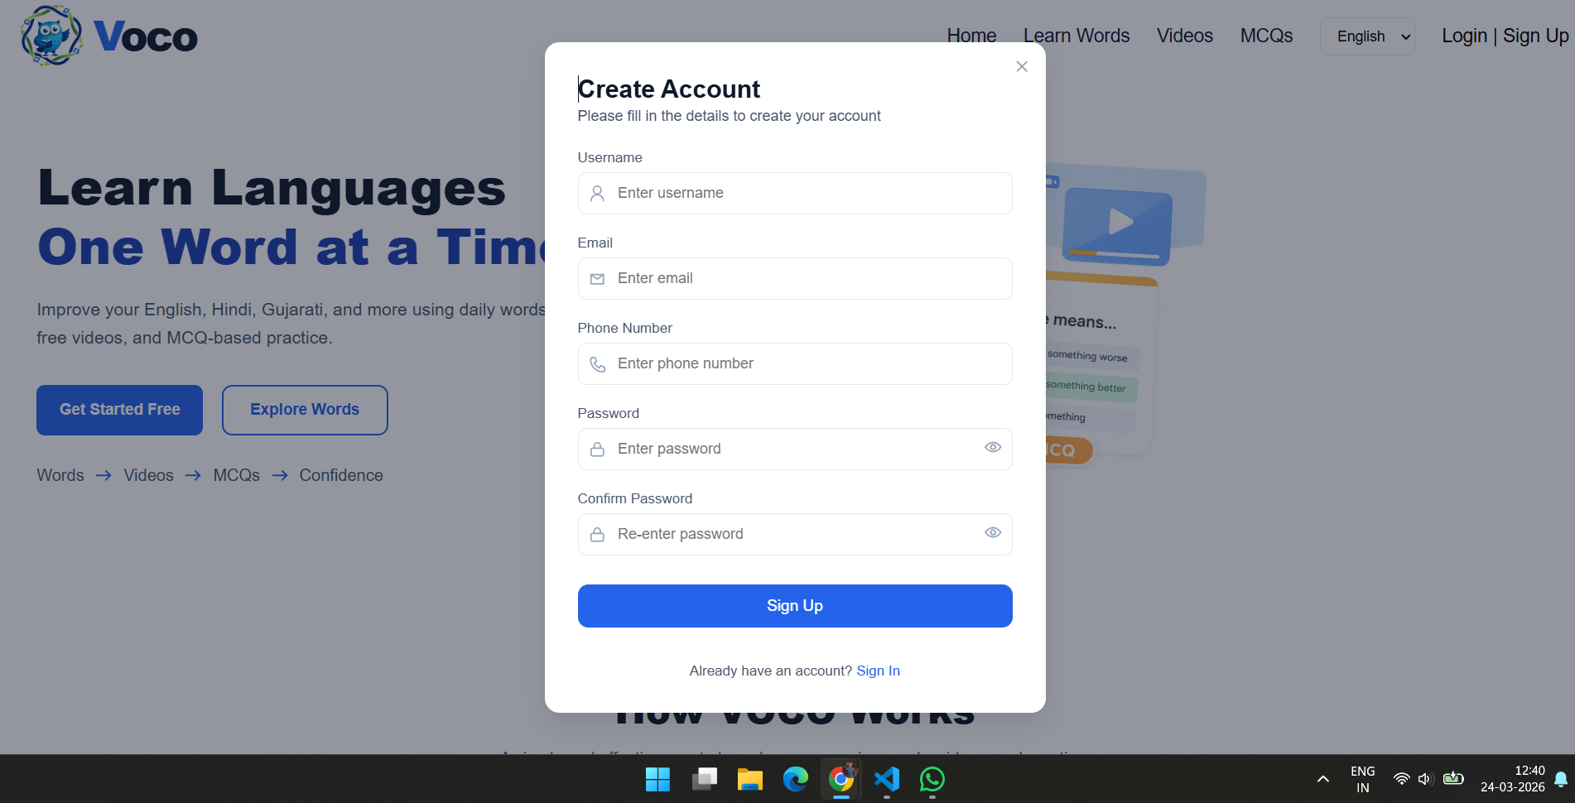
- OTP Verify Page

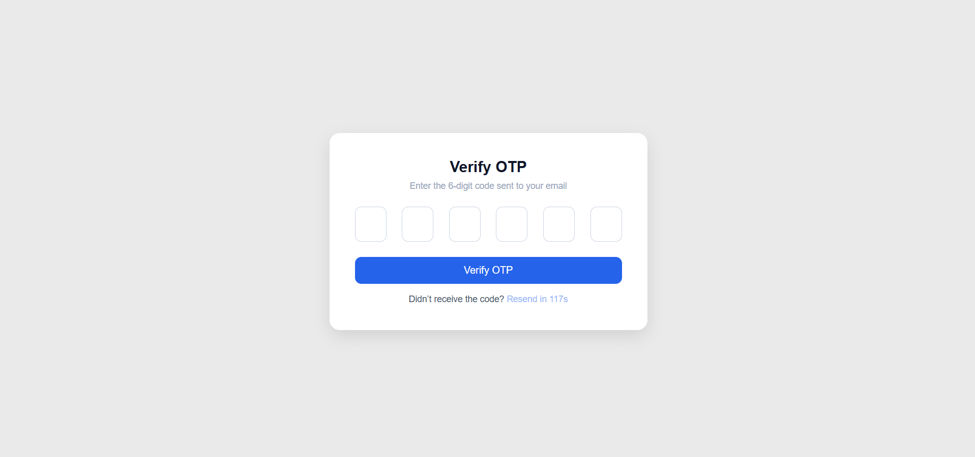

- Learn Words Page
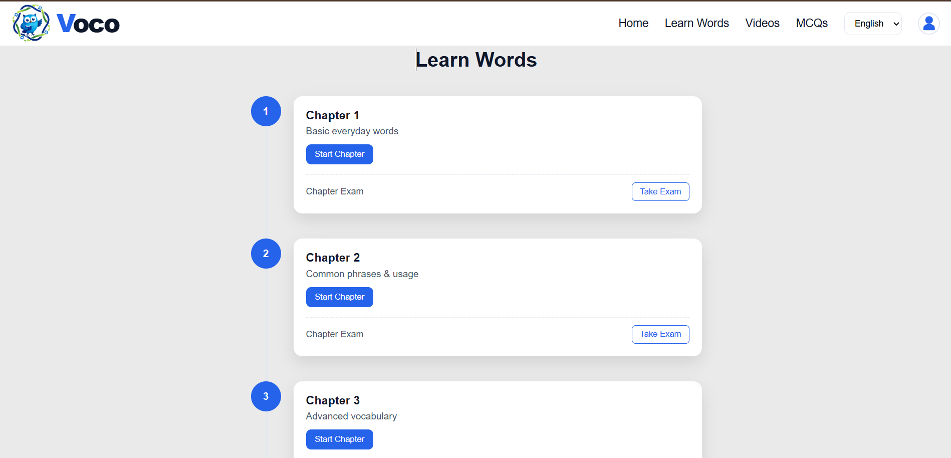

- Videos Page
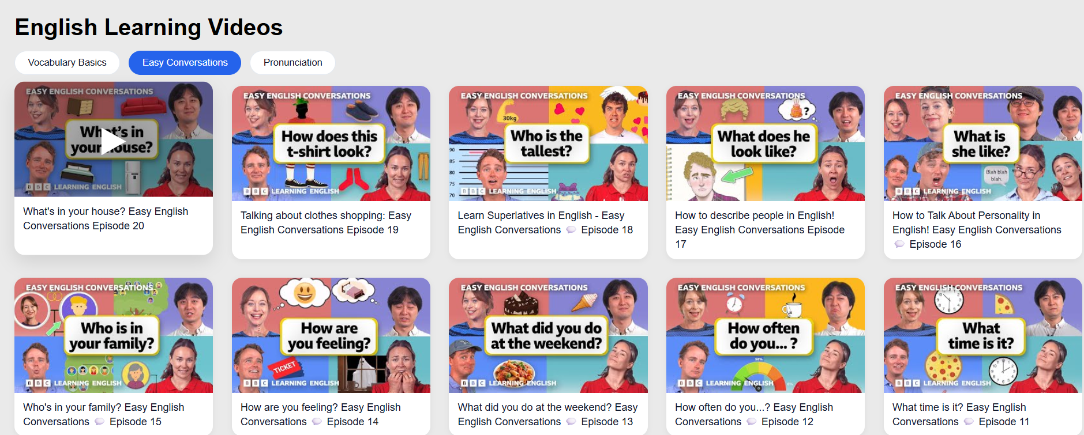

- MCQs Page
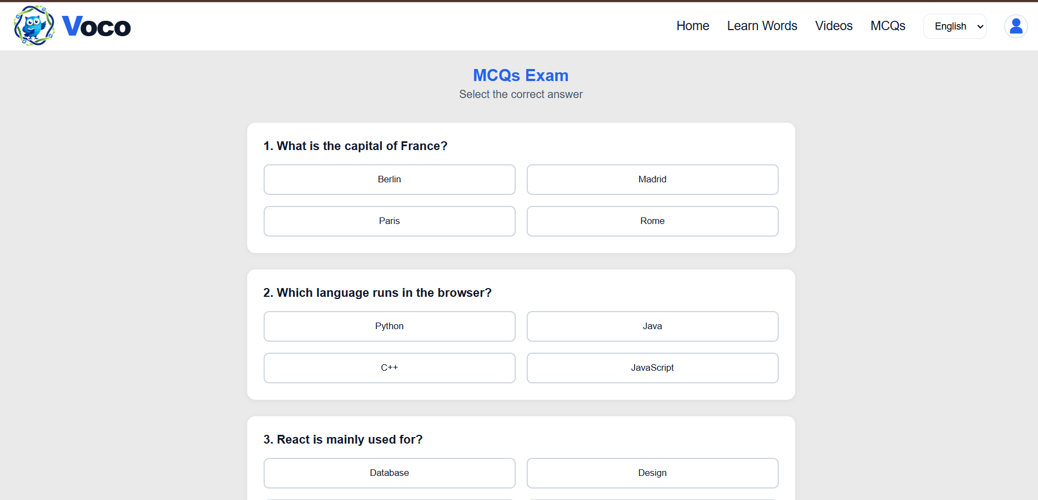
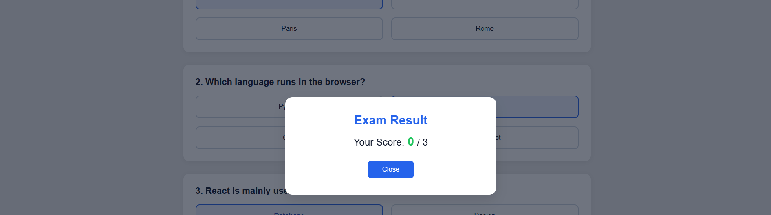

- AI Conversation Page
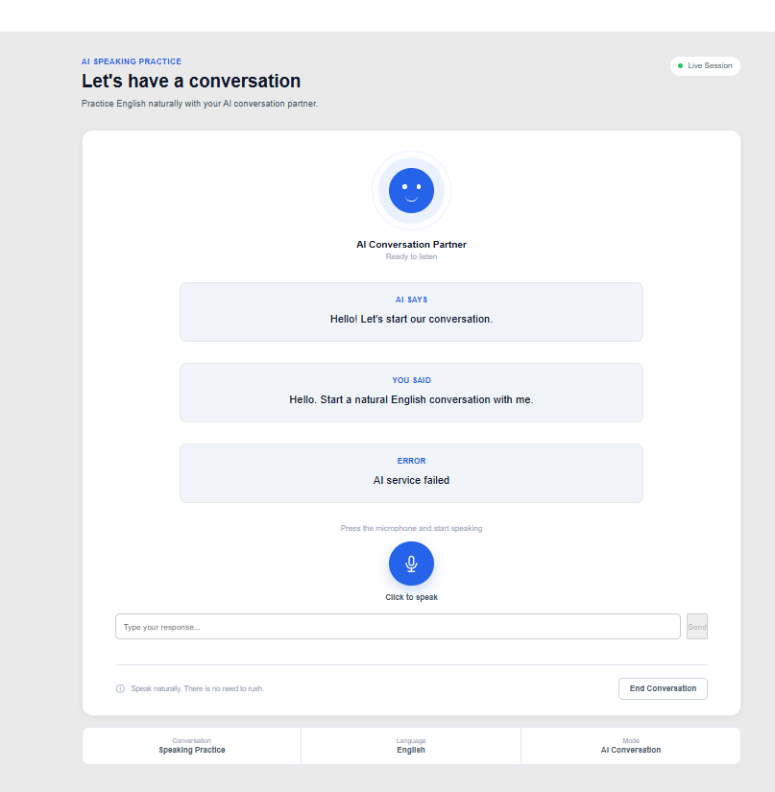
- Dasabord Page
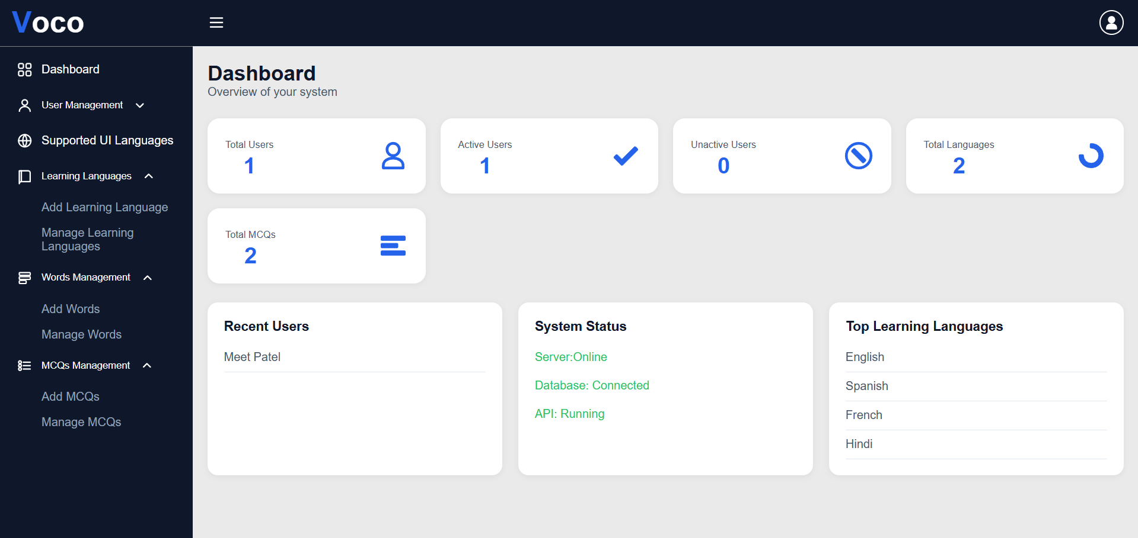

- Supported langauge
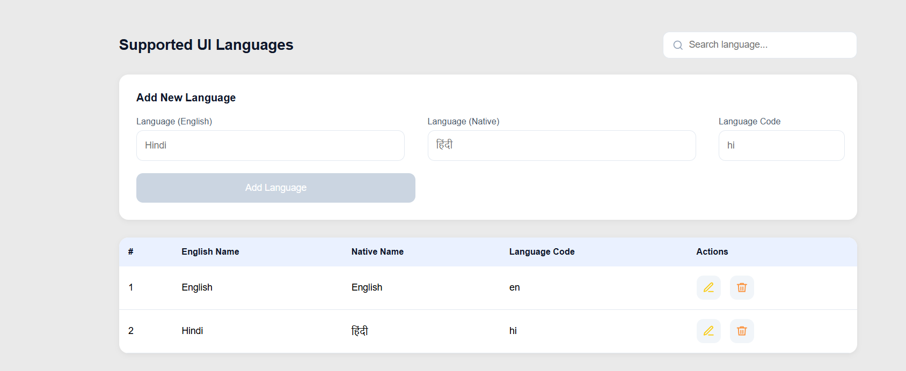
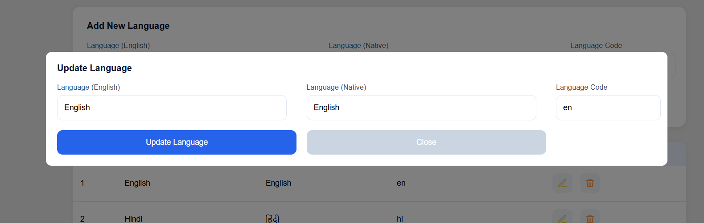

- Add New Learning Language page
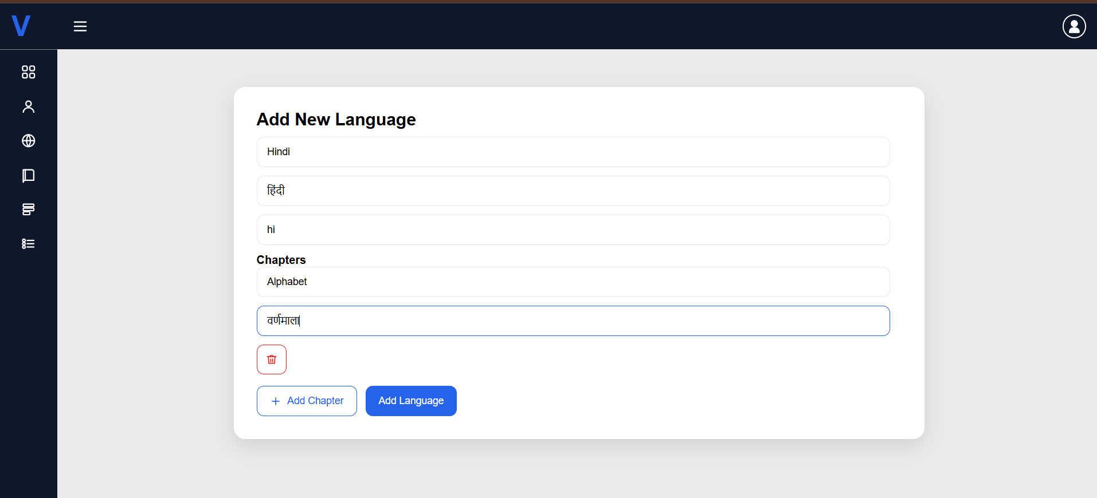

- View All Learning Language Page
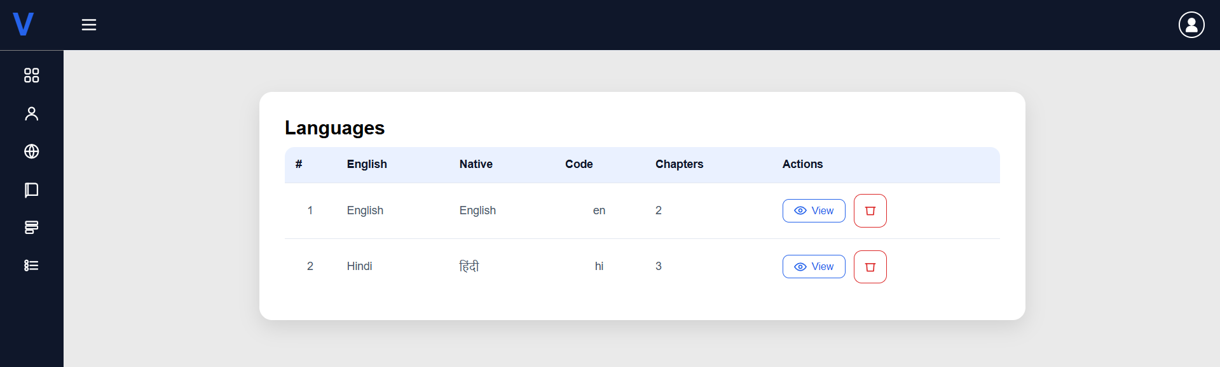

- View All Chapters from Learning Language Page
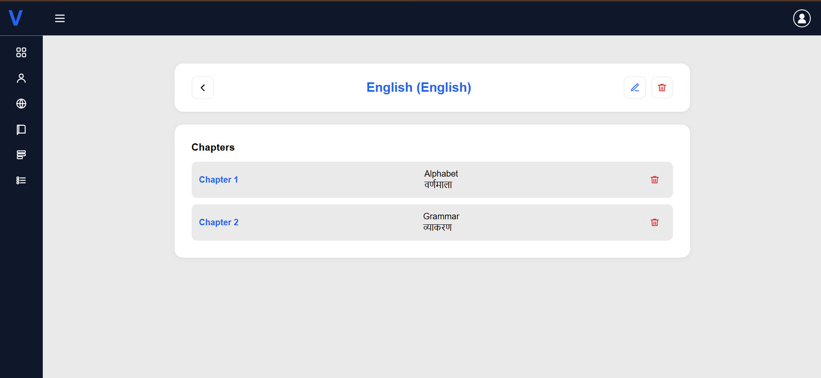

- Update Learning Language Page
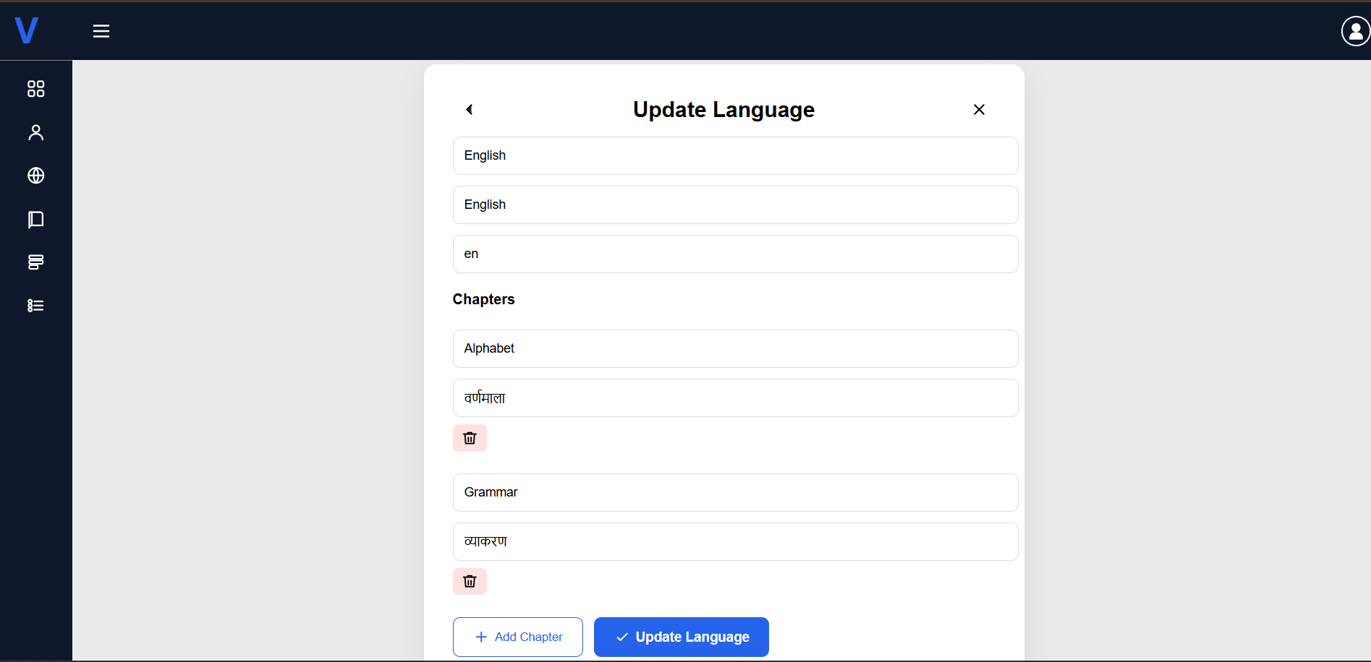

- Add Learning Words Page
if admin select the Content Type = Text Block
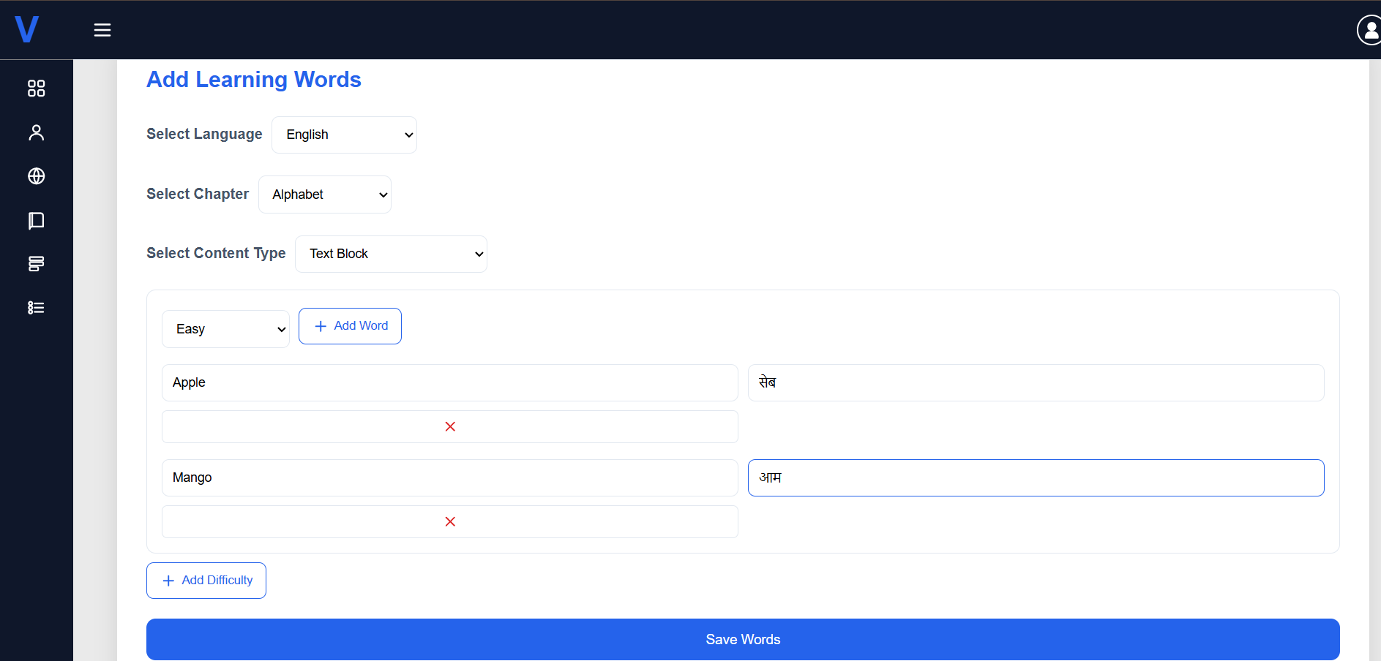
if admin select the Content Type = TextArea
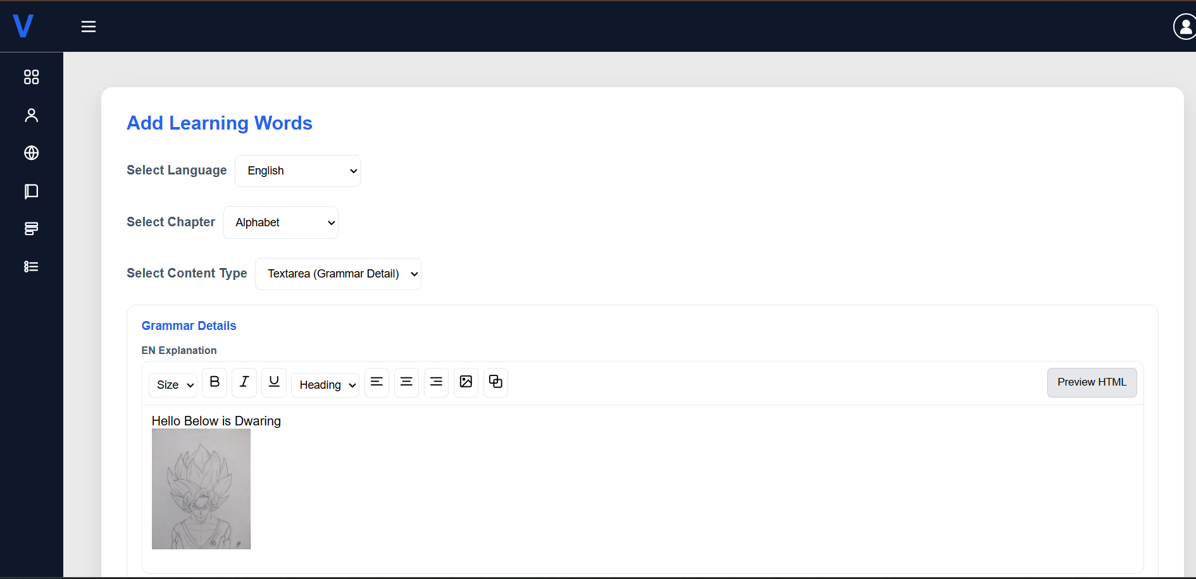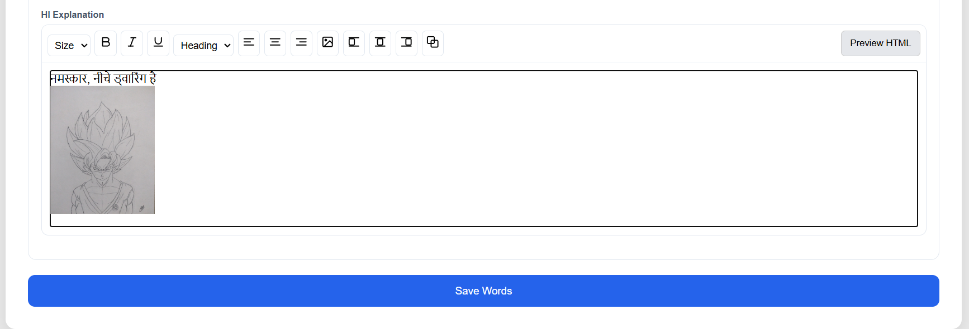

- Add MCQs Page
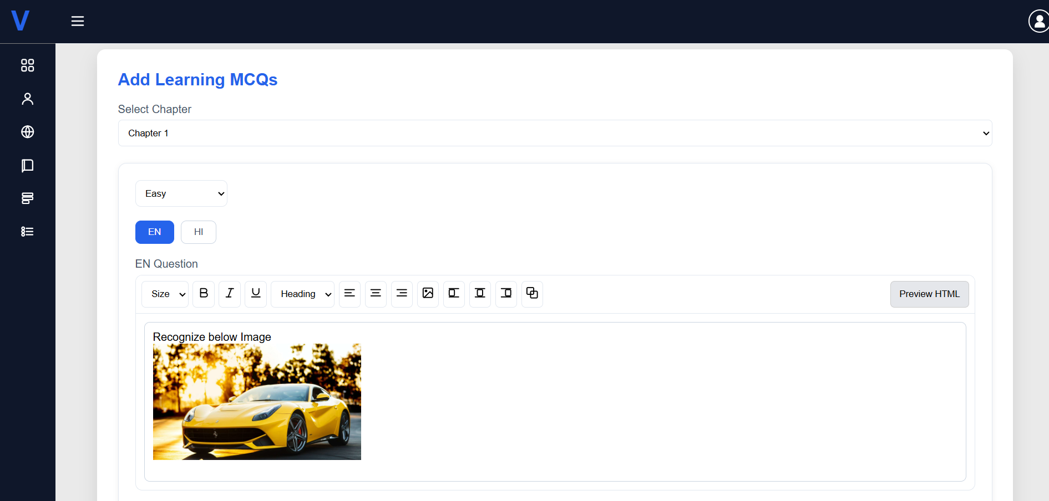
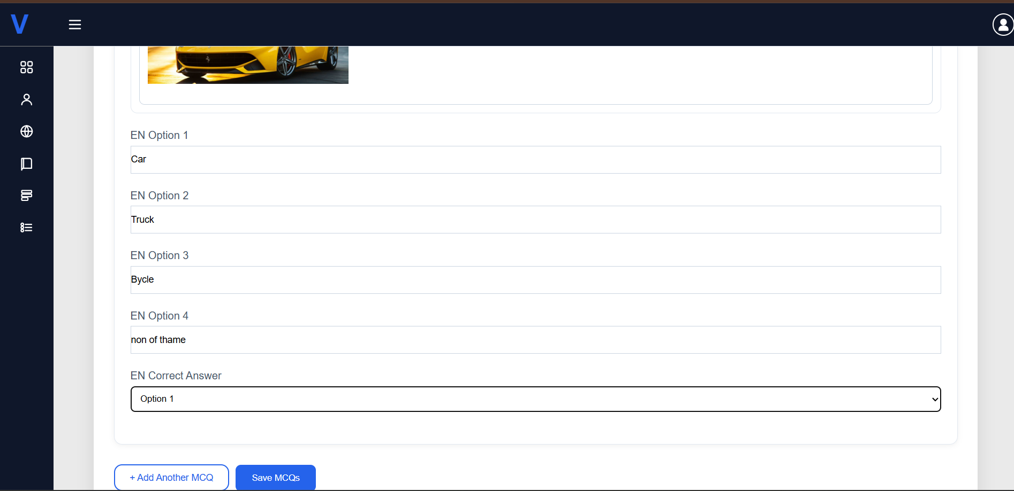

6.10 Proposed Enhancement

6.11 Project Closure Report

6.12 Conclusion

The VOCO platform is a modern language learning system developed using the MERN stack, designed to provide an interactive and user-friendly environment for learners. It offers key features such as secure authentication, multi-language learning modules, chapter-wise and final examinations, progress tracking, and certificate generation. The system ensures a smooth and scalable user experience through efficient frontend and backend integration.
The project follows Agile methodology, enabling incremental development, continuous improvement, and better feature management across multiple sprints. This approach helped in building a robust system with well-structured modules like user management, admin controls, and assessment systems.
Overall, VOCO provides an effective digital solution for language learning, combining technology with structured content delivery. The platform also has strong potential for future enhancements such as AI-based personalized learning, voice recognition, and mobile application support, making it a scalable and future-ready system.

6.13 Bibliography

- MongoDB Documentation.
Available at: https://www.mongodb.com/docs/
- Express.js Official Documentation.
Available at: https://expressjs.com/
- React Official Documentation.
Available at: https://react.dev/
- Node.js Documentation.
Available at: https://nodejs.org/en/docs/
- JWT Introduction and Documentation.
Available at: https://jwt.io/introduction
- i18next Documentation.
Available at: https://www.i18next.com/
- Nodemailer Documentation.
Available at: https://nodemailer.com/about/
- Twilio Documentation.
Available at: https://www.twilio.com/docs
- GitHub.
Available at: https://github.com/

